# Study Design

The data linked to from the course website represent data collected from the accelerometers from the Samsung Galaxy S smartphone. A full description is available at the site where the data was obtained:

<http://archive.ics.uci.edu/ml/datasets/Human+Activity+Recognition+Using+Smartphones>

Here are the data for the project:

<https://d396qusza40orc.cloudfront.net/getdata%2Fprojectfiles%2FUCI%20HAR%20Dataset.zip>

For more information contact: [activityrecognition@smartlab.ws](mailto:activityrecognition@smartlab.ws)

The experiments have been carried out with a group of 30 volunteers within an age bracket of 19-48 years. Each person performed six activities (WALKING, WALKING_UPSTAIRS, WALKING_DOWNSTAIRS, SITTING, STANDING, LAYING) wearing a smartphone (Samsung Galaxy S II) on the waist. Using its embedded accelerometer and gyroscope, we captured 3-axial linear acceleration and 3-axial angular velocity at a constant rate of 50Hz. The experiments have been video-recorded to label the data manually. The obtained dataset has been randomly partitioned into two sets, where 70% of the volunteers was selected for generating the training data and 30% the test data.

The sensor signals (accelerometer and gyroscope) were pre-processed by applying noise filters and then sampled in fixed-width sliding windows of 2.56 sec and 50% overlap (128 readings/window). The sensor acceleration signal, which has gravitational and body motion components, was separated using a Butterworth low-pass filter into body acceleration and gravity. The gravitational force is assumed to have only low frequency components, therefore a filter with 0.3 Hz cutoff frequency was used. From each window, a vector of features was obtained by calculating variables from the time and frequency domain.

Each record contains the following: triaxial acceleration from the accelerometer (total acceleration) and the estimated body acceleration, triaxial angular velocity from the gyroscope, a 561-feature vector with time and frequency domain variables, an activity label, and an identifier of the subject who carried out the experiment. Features are normalized and bounded within [-1,1].

The features selected for this database come from the accelerometer and gyroscope 3-axial raw signals tAcc-XYZ and tGyro-XYZ. These time domain signals (prefix 't' to denote time) were captured at a constant rate of 50 Hz. Then they were filtered using a median filter and a 3rd order low pass Butterworth filter with a corner frequency of 20 Hz to remove noise. Similarly, the acceleration signal was then separated into body and gravity acceleration signals (tBodyAcc-XYZ and tGravityAcc-XYZ) using another low pass Butterworth filter with a corner frequency of 0.3 Hz. Subsequently, the body linear acceleration and angular velocity were derived in time to obtain Jerk signals (tBodyAccJerk-XYZ and tBodyGyroJerk-XYZ). Also the magnitude of these three-dimensional signals were calculated using the Euclidean norm (tBodyAccMag, tGravityAccMag, tBodyAccJerkMag, tBodyGyroMag, tBodyGyroJerkMag). Finally a Fast Fourier Transform (FFT) was applied to some of these signals producing fBodyAcc-XYZ, fBodyAccJerk-XYZ, fBodyGyro-XYZ, fBodyAccJerkMag, fBodyGyroMag, fBodyGyroJerkMag. (Note the 'f' to indicate frequency domain signals). These signals were used to estimate variables of the feature vector for each pattern: '-XYZ' is used to denote 3-axial signals in the X, Y and Z directions.

# Codebook for combined_tidy

Autogenerated data summary from dataMaid

2019-05-22 10:31:22

# Data report overview

The dataset examined has the following dimensions:

|  |  |
| --- | --- |
| Feature | Result |
| Number of observations | 10299 |
| Number of variables | 70 |

# Codebook summary table

|  |  |  |  |
| --- | --- | --- | --- |
| Variable | Class | # unique values | Missing |
| **MeanBodyAccelerationSignalXAxis** | numeric | 10292 | 0.00 % |
| **MeanBodyAccelerationSignalYAxis** | numeric | 10299 | 0.00 % |
| **MeanBodyAccelerationSignalZAxis** | numeric | 10293 | 0.00 % |
| **MeanGravityAccelerationSignalXAxis** | numeric | 10296 | 0.00 % |
| **MeanGravityAccelerationSignalYAxis** | numeric | 10298 | 0.00 % |
| **MeanGravityAccelerationSignalZAxis** | numeric | 10299 | 0.00 % |
| **MeanBodyAccelerationJerkSignalXAxis** | numeric | 10299 | 0.00 % |
| **MeanBodyAccelerationJerkSignalYAxis** | numeric | 10299 | 0.00 % |
| **MeanBodyAccelerationJerkSignalZAxis** | numeric | 10299 | 0.00 % |
| **MeanBodyGyroSignalXAxis** | numeric | 10298 | 0.00 % |
| **MeanBodyGyroSignalYAxis** | numeric | 10299 | 0.00 % |
| **MeanBodyGyroSignalZAxis** | numeric | 10297 | 0.00 % |
| **MeanBodyGyroJerkSignalXAxis** | numeric | 10295 | 0.00 % |
| **MeanBodyGyroJerkSignalYAxis** | numeric | 10299 | 0.00 % |
| **MeanBodyGyroJerkSignalZAxis** | numeric | 10298 | 0.00 % |
| **MeanMagnitudeOfBodyAccelerationSignal** | numeric | 10296 | 0.00 % |
| **MeanMagnitudeOfGravityAccelerationSignal** | numeric | 10296 | 0.00 % |
| **MeanMagnitudeOfBodyAccelerationJerkSignal** | numeric | 10292 | 0.00 % |
| **MeanMagnitudeOfBodyGyroSignal** | numeric | 10298 | 0.00 % |
| **MeanMagnitudeOfBodyGyroJerkSignal** | numeric | 10293 | 0.00 % |
| **MeanFrequencyDomainBodyAccelerationSignalXAxis** | numeric | 10295 | 0.00 % |
| **MeanFrequencyDomainBodyAccelerationSignalYAxis** | numeric | 10292 | 0.00 % |
| **MeanFrequencyDomainBodyAccelerationSignalZAxis** | numeric | 10295 | 0.00 % |
| **MeanFrequencyDomainBodyAccelerationJerkSignalXAxis** | numeric | 10293 | 0.00 % |
| **MeanFrequencyDomainBodyAccelerationJerkSignalYAxis** | numeric | 10296 | 0.00 % |
| **MeanFrequencyDomainBodyAccelerationJerkSignalZAxis** | numeric | 10294 | 0.00 % |
| **MeanFrequencyDomainBodyGyroSignalXAxis** | numeric | 10297 | 0.00 % |
| **MeanFrequencyDomainBodyGyroSignalYAxis** | numeric | 10296 | 0.00 % |
| **MeanFrequencyDomainBodyGyroSignalZAxis** | numeric | 10297 | 0.00 % |
| **MeanMagnitudeOfBodyAccelerationFrequencyDomainSignal** | numeric | 10296 | 0.00 % |
| **MeanMagnitudeOfBodyAccelerationJerkFrequencyDomainSignal** | numeric | 10290 | 0.00 % |
| **MeanMagnitudeOfBodyGyroFrequencyDomainSignal** | numeric | 10297 | 0.00 % |
| **MeanMagnitudeOfBodyGyroJerkFrequencyDomainSignal** | numeric | 10293 | 0.00 % |
| **StdBodyAccelerationSignalXAxis** | numeric | 10295 | 0.00 % |
| **StdBodyAccelerationSignalYAxis** | numeric | 10297 | 0.00 % |
| **StdBodyAccelerationSignalZAxis** | numeric | 10297 | 0.00 % |
| **StdGravityAccelerationSignalXAxis** | numeric | 10288 | 0.00 % |
| **StdGravityAccelerationSignalYAxis** | numeric | 10293 | 0.00 % |
| **StdGravityAccelerationSignalZAxis** | numeric | 10296 | 0.00 % |
| **StdBodyAccelerationJerkSignalXAxis** | numeric | 10290 | 0.00 % |
| **StdBodyAccelerationJerkSignalYAxis** | numeric | 10296 | 0.00 % |
| **StdBodyAccelerationJerkSignalZAxis** | numeric | 10293 | 0.00 % |
| **StdBodyGyroSignalXAxis** | numeric | 10292 | 0.00 % |
| **StdBodyGyroSignalYAxis** | numeric | 10296 | 0.00 % |
| **StdBodyGyroSignalZAxis** | numeric | 10296 | 0.00 % |
| **StdBodyGyroJerkSignalXAxis** | numeric | 10292 | 0.00 % |
| **StdBodyGyroJerkSignalYAxis** | numeric | 10295 | 0.00 % |
| **StdBodyGyroJerkSignalZAxis** | numeric | 10291 | 0.00 % |
| **StdMagnitudeOfBodyAccelerationSignal** | numeric | 10294 | 0.00 % |
| **StdMagnitudeOfGravityAccelerationSignal** | numeric | 10294 | 0.00 % |
| **StdMagnitudeOfBodyAccelerationJerkSignal** | numeric | 10294 | 0.00 % |
| **StdMagnitudeOfBodyGyroSignal** | numeric | 10298 | 0.00 % |
| **StdMagnitudeOfBodyGyroJerkSignal** | numeric | 10297 | 0.00 % |
| **StdFrequencyDomainBodyAccelerationSignalXAxis** | numeric | 10294 | 0.00 % |
| **StdFrequencyDomainBodyAccelerationSignalYAxis** | numeric | 10297 | 0.00 % |
| **StdFrequencyDomainBodyAccelerationSignalZAxis** | numeric | 10296 | 0.00 % |
| **StdFrequencyDomainBodyAccelerationJerkSignalXAxis** | numeric | 10291 | 0.00 % |
| **StdFrequencyDomainBodyAccelerationJerkSignalYAxis** | numeric | 10294 | 0.00 % |
| **StdFrequencyDomainBodyAccelerationJerkSignalZAxis** | numeric | 10290 | 0.00 % |
| **StdFrequencyDomainBodyGyroSignalXAxis** | numeric | 10297 | 0.00 % |
| **StdFrequencyDomainBodyGyroSignalYAxis** | numeric | 10293 | 0.00 % |
| **StdFrequencyDomainBodyGyroSignalZAxis** | numeric | 10295 | 0.00 % |
| **StdMagnitudeOfBodyAccelerationFrequencyDomainSignal** | numeric | 10298 | 0.00 % |
| **StdMagnitudeOfBodyAccelerationJerkFrequencyDomainSignal** | numeric | 10296 | 0.00 % |
| **StdMagnitudeOfBodyGyroFrequencyDomainSignal** | numeric | 10296 | 0.00 % |
| **StdMagnitudeOfBodyGyroJerkFrequencyDomainSignal** | numeric | 10292 | 0.00 % |
| **activitynumber** | integer | 6 | 0.00 % |
| **activityname** | factor | 6 | 0.00 % |
| **volunteerid** | integer | 30 | 0.00 % |
| **sample** | character | 2 | 0.00 % |

# Variable list

## MeanBodyAccelerationSignalXAxis

|  |  |
| --- | --- |
| Feature | Result |
| Variable type | numeric |
| Number of missing obs. | 0 (0 %) |
| Number of unique values | 10292 |
| Median | 0.28 |
| 1st and 3rd quartiles | 0.26; 0.29 |
| Min. and max. | -1; 1 |

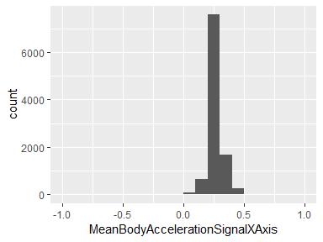

## MeanBodyAccelerationSignalYAxis

|  |  |
| --- | --- |
| Feature | Result |
| Variable type | numeric |
| Number of missing obs. | 0 (0 %) |
| Number of unique values | 10299 |
| Median | -0.02 |
| 1st and 3rd quartiles | -0.02; -0.01 |
| Min. and max. | -1; 1 |

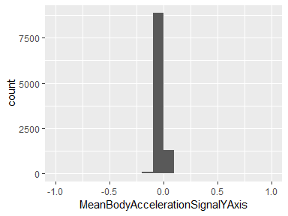

## MeanBodyAccelerationSignalZAxis

|  |  |
| --- | --- |
| Feature | Result |
| Variable type | numeric |
| Number of missing obs. | 0 (0 %) |
| Number of unique values | 10293 |
| Median | -0.11 |
| 1st and 3rd quartiles | -0.12; -0.1 |
| Min. and max. | -1; 1 |

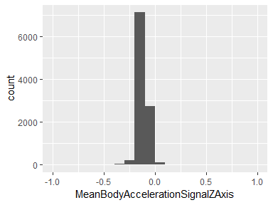

## MeanGravityAccelerationSignalXAxis

|  |  |
| --- | --- |
| Feature | Result |
| Variable type | numeric |
| Number of missing obs. | 0 (0 %) |
| Number of unique values | 10296 |
| Median | 0.92 |
| 1st and 3rd quartiles | 0.81; 0.95 |
| Min. and max. | -1; 1 |

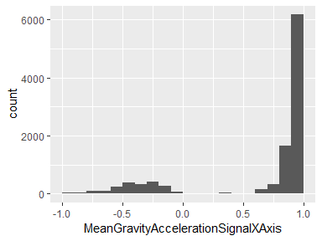

## MeanGravityAccelerationSignalYAxis

|  |  |
| --- | --- |
| Feature | Result |
| Variable type | numeric |
| Number of missing obs. | 0 (0 %) |
| Number of unique values | 10298 |
| Median | -0.14 |
| 1st and 3rd quartiles | -0.24; 0.12 |
| Min. and max. | -1; 1 |

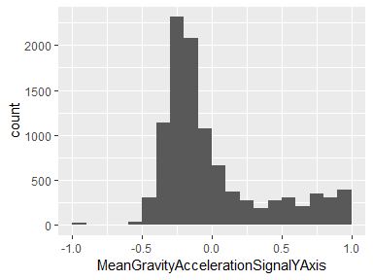

## MeanGravityAccelerationSignalZAxis

|  |  |
| --- | --- |
| Feature | Result |
| Variable type | numeric |
| Number of missing obs. | 0 (0 %) |
| Number of unique values | 10299 |
| Median | 0.04 |
| 1st and 3rd quartiles | -0.12; 0.22 |
| Min. and max. | -1; 1 |

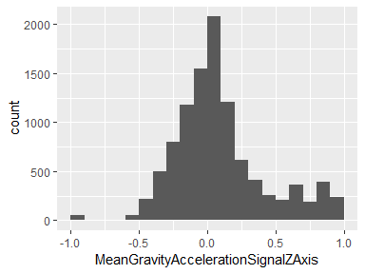

## MeanBodyAccelerationJerkSignalXAxis

|  |  |
| --- | --- |
| Feature | Result |
| Variable type | numeric |
| Number of missing obs. | 0 (0 %) |
| Number of unique values | 10299 |
| Median | 0.08 |
| 1st and 3rd quartiles | 0.06; 0.09 |
| Min. and max. | -1; 1 |

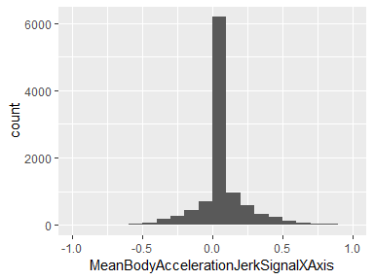

## MeanBodyAccelerationJerkSignalYAxis

|  |  |
| --- | --- |
| Feature | Result |
| Variable type | numeric |
| Number of missing obs. | 0 (0 %) |
| Number of unique values | 10299 |
| Median | 0.01 |
| 1st and 3rd quartiles | -0.02; 0.03 |
| Min. and max. | -1; 1 |

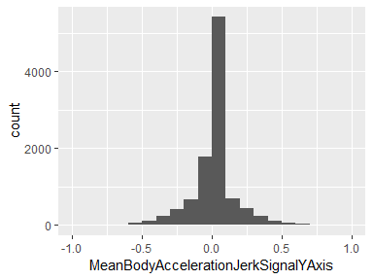

## MeanBodyAccelerationJerkSignalZAxis

|  |  |
| --- | --- |
| Feature | Result |
| Variable type | numeric |
| Number of missing obs. | 0 (0 %) |
| Number of unique values | 10299 |
| Median | 0 |
| 1st and 3rd quartiles | -0.03; 0.02 |
| Min. and max. | -1; 1 |

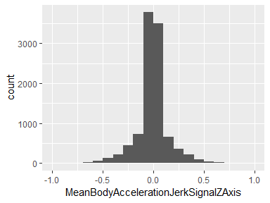

## MeanBodyGyroSignalXAxis

|  |  |
| --- | --- |
| Feature | Result |
| Variable type | numeric |
| Number of missing obs. | 0 (0 %) |
| Number of unique values | 10298 |
| Median | -0.03 |
| 1st and 3rd quartiles | -0.05; -0.01 |
| Min. and max. | -1; 1 |

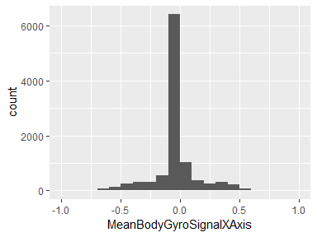

## MeanBodyGyroSignalYAxis

|  |  |
| --- | --- |
| Feature | Result |
| Variable type | numeric |
| Number of missing obs. | 0 (0 %) |
| Number of unique values | 10299 |
| Median | -0.07 |
| 1st and 3rd quartiles | -0.1; -0.05 |
| Min. and max. | -1; 1 |

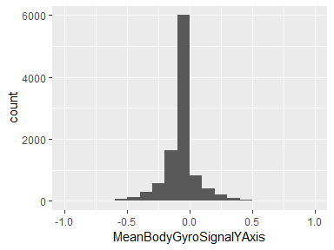

## MeanBodyGyroSignalZAxis

|  |  |
| --- | --- |
| Feature | Result |
| Variable type | numeric |
| Number of missing obs. | 0 (0 %) |
| Number of unique values | 10297 |
| Median | 0.09 |
| 1st and 3rd quartiles | 0.06; 0.11 |
| Min. and max. | -1; 1 |

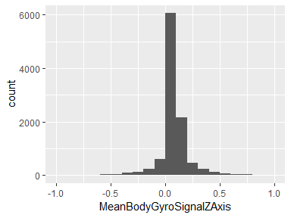

## MeanBodyGyroJerkSignalXAxis

|  |  |
| --- | --- |
| Feature | Result |
| Variable type | numeric |
| Number of missing obs. | 0 (0 %) |
| Number of unique values | 10295 |
| Median | -0.1 |
| 1st and 3rd quartiles | -0.12; -0.08 |
| Min. and max. | -1; 1 |

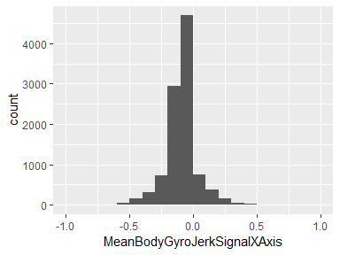

## MeanBodyGyroJerkSignalYAxis

|  |  |
| --- | --- |
| Feature | Result |
| Variable type | numeric |
| Number of missing obs. | 0 (0 %) |
| Number of unique values | 10299 |
| Median | -0.04 |
| 1st and 3rd quartiles | -0.06; -0.03 |
| Min. and max. | -1; 1 |

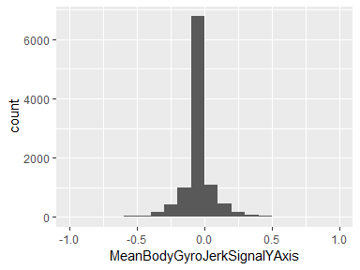

## MeanBodyGyroJerkSignalZAxis

|  |  |
| --- | --- |
| Feature | Result |
| Variable type | numeric |
| Number of missing obs. | 0 (0 %) |
| Number of unique values | 10298 |
| Median | -0.05 |
| 1st and 3rd quartiles | -0.08; -0.03 |
| Min. and max. | -1; 1 |

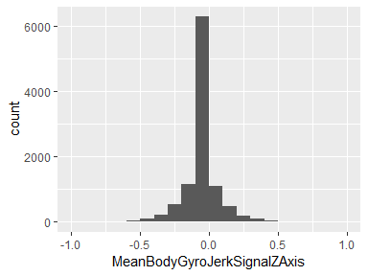

## MeanMagnitudeOfBodyAccelerationSignal

|  |  |
| --- | --- |
| Feature | Result |
| Variable type | numeric |
| Number of missing obs. | 0 (0 %) |
| Number of unique values | 10296 |
| Median | -0.87 |
| 1st and 3rd quartiles | -0.98; -0.12 |
| Min. and max. | -1; 1 |

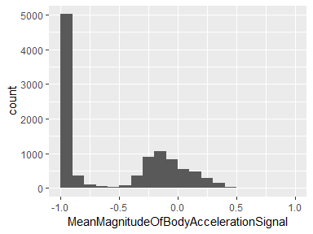

## MeanMagnitudeOfGravityAccelerationSignal

|  |  |
| --- | --- |
| Feature | Result |
| Variable type | numeric |
| Number of missing obs. | 0 (0 %) |
| Number of unique values | 10296 |
| Median | -0.87 |
| 1st and 3rd quartiles | -0.98; -0.12 |
| Min. and max. | -1; 1 |

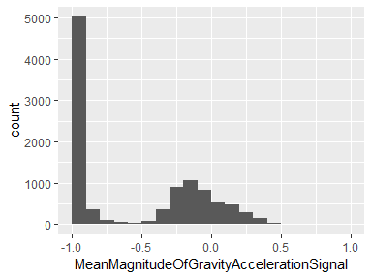

## MeanMagnitudeOfBodyAccelerationJerkSignal

|  |  |
| --- | --- |
| Feature | Result |
| Variable type | numeric |
| Number of missing obs. | 0 (0 %) |
| Number of unique values | 10292 |
| Median | -0.95 |
| 1st and 3rd quartiles | -0.99; -0.3 |
| Min. and max. | -1; 1 |

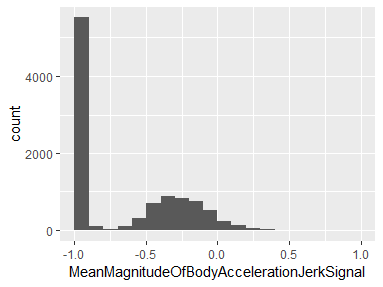

## MeanMagnitudeOfBodyGyroSignal

|  |  |
| --- | --- |
| Feature | Result |
| Variable type | numeric |
| Number of missing obs. | 0 (0 %) |
| Number of unique values | 10298 |
| Median | -0.82 |
| 1st and 3rd quartiles | -0.98; -0.25 |
| Min. and max. | -1; 1 |

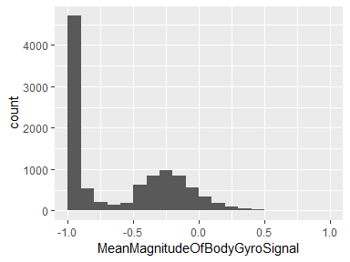

## MeanMagnitudeOfBodyGyroJerkSignal

|  |  |
| --- | --- |
| Feature | Result |
| Variable type | numeric |
| Number of missing obs. | 0 (0 %) |
| Number of unique values | 10293 |
| Median | -0.96 |
| 1st and 3rd quartiles | -0.99; -0.55 |
| Min. and max. | -1; 1 |

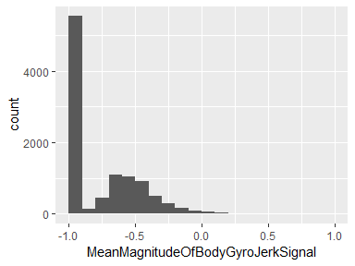

## MeanFrequencyDomainBodyAccelerationSignalXAxis

|  |  |
| --- | --- |
| Feature | Result |
| Variable type | numeric |
| Number of missing obs. | 0 (0 %) |
| Number of unique values | 10295 |
| Median | -0.95 |
| 1st and 3rd quartiles | -0.99; -0.26 |
| Min. and max. | -1; 1 |

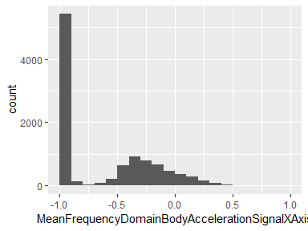

## MeanFrequencyDomainBodyAccelerationSignalYAxis

|  |  |
| --- | --- |
| Feature | Result |
| Variable type | numeric |
| Number of missing obs. | 0 (0 %) |
| Number of unique values | 10292 |
| Median | -0.86 |
| 1st and 3rd quartiles | -0.98; -0.1 |
| Min. and max. | -1; 1 |

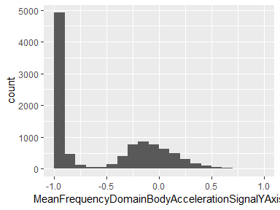

## MeanFrequencyDomainBodyAccelerationSignalZAxis

|  |  |
| --- | --- |
| Feature | Result |
| Variable type | numeric |
| Number of missing obs. | 0 (0 %) |
| Number of unique values | 10295 |
| Median | -0.9 |
| 1st and 3rd quartiles | -0.98; -0.37 |
| Min. and max. | -1; 1 |

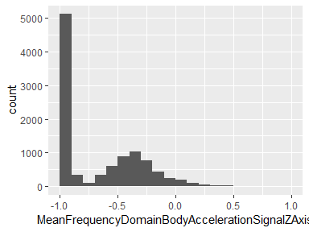

## MeanFrequencyDomainBodyAccelerationJerkSignalXAxis

|  |  |
| --- | --- |
| Feature | Result |
| Variable type | numeric |
| Number of missing obs. | 0 (0 %) |
| Number of unique values | 10293 |
| Median | -0.95 |
| 1st and 3rd quartiles | -0.99; -0.33 |
| Min. and max. | -1; 1 |

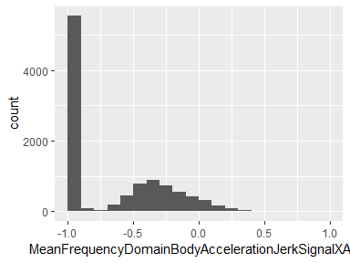

## MeanFrequencyDomainBodyAccelerationJerkSignalYAxis

|  |  |
| --- | --- |
| Feature | Result |
| Variable type | numeric |
| Number of missing obs. | 0 (0 %) |
| Number of unique values | 10296 |
| Median | -0.93 |
| 1st and 3rd quartiles | -0.98; -0.26 |
| Min. and max. | -1; 1 |

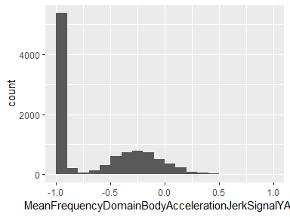

## MeanFrequencyDomainBodyAccelerationJerkSignalZAxis

|  |  |
| --- | --- |
| Feature | Result |
| Variable type | numeric |
| Number of missing obs. | 0 (0 %) |
| Number of unique values | 10294 |
| Median | -0.95 |
| 1st and 3rd quartiles | -0.99; -0.51 |
| Min. and max. | -1; 1 |

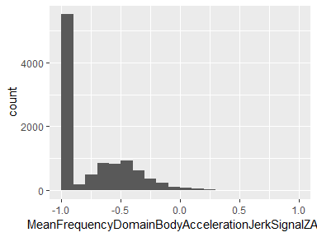

## MeanFrequencyDomainBodyGyroSignalXAxis

|  |  |
| --- | --- |
| Feature | Result |
| Variable type | numeric |
| Number of missing obs. | 0 (0 %) |
| Number of unique values | 10297 |
| Median | -0.89 |
| 1st and 3rd quartiles | -0.99; -0.38 |
| Min. and max. | -1; 1 |

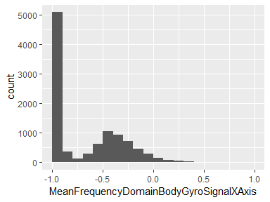

## MeanFrequencyDomainBodyGyroSignalYAxis

|  |  |
| --- | --- |
| Feature | Result |
| Variable type | numeric |
| Number of missing obs. | 0 (0 %) |
| Number of unique values | 10296 |
| Median | -0.92 |
| 1st and 3rd quartiles | -0.98; -0.47 |
| Min. and max. | -1; 1 |

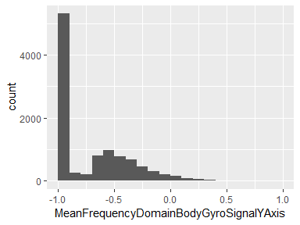

## MeanFrequencyDomainBodyGyroSignalZAxis

|  |  |
| --- | --- |
| Feature | Result |
| Variable type | numeric |
| Number of missing obs. | 0 (0 %) |
| Number of unique values | 10297 |
| Median | -0.89 |
| 1st and 3rd quartiles | -0.99; -0.32 |
| Min. and max. | -1; 1 |

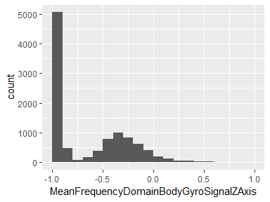

## MeanMagnitudeOfBodyAccelerationFrequencyDomainSignal

|  |  |
| --- | --- |
| Feature | Result |
| Variable type | numeric |
| Number of missing obs. | 0 (0 %) |
| Number of unique values | 10296 |
| Median | -0.88 |
| 1st and 3rd quartiles | -0.98; -0.22 |
| Min. and max. | -1; 1 |

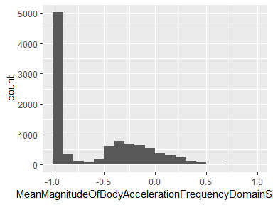

## MeanMagnitudeOfBodyAccelerationJerkFrequencyDomainSignal

|  |  |
| --- | --- |
| Feature | Result |
| Variable type | numeric |
| Number of missing obs. | 0 (0 %) |
| Number of unique values | 10290 |
| Median | -0.93 |
| 1st and 3rd quartiles | -0.99; -0.26 |
| Min. and max. | -1; 1 |

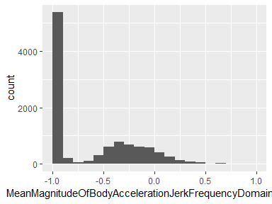

## MeanMagnitudeOfBodyGyroFrequencyDomainSignal

|  |  |
| --- | --- |
| Feature | Result |
| Variable type | numeric |
| Number of missing obs. | 0 (0 %) |
| Number of unique values | 10297 |
| Median | -0.88 |
| 1st and 3rd quartiles | -0.98; -0.45 |
| Min. and max. | -1; 1 |

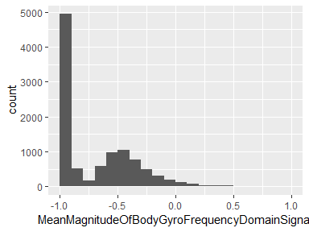

## MeanMagnitudeOfBodyGyroJerkFrequencyDomainSignal

|  |  |
| --- | --- |
| Feature | Result |
| Variable type | numeric |
| Number of missing obs. | 0 (0 %) |
| Number of unique values | 10293 |
| Median | -0.95 |
| 1st and 3rd quartiles | -0.99; -0.61 |
| Min. and max. | -1; 1 |

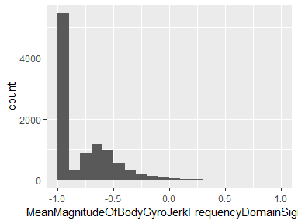

## StdBodyAccelerationSignalXAxis

|  |  |
| --- | --- |
| Feature | Result |
| Variable type | numeric |
| Number of missing obs. | 0 (0 %) |
| Number of unique values | 10295 |
| Median | -0.94 |
| 1st and 3rd quartiles | -0.99; -0.25 |
| Min. and max. | -1; 1 |

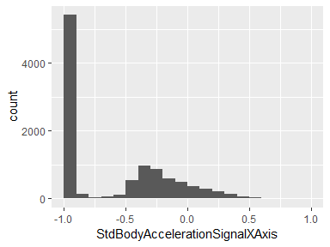

## StdBodyAccelerationSignalYAxis

|  |  |
| --- | --- |
| Feature | Result |
| Variable type | numeric |
| Number of missing obs. | 0 (0 %) |
| Number of unique values | 10297 |
| Median | -0.84 |
| 1st and 3rd quartiles | -0.98; -0.06 |
| Min. and max. | -1; 1 |

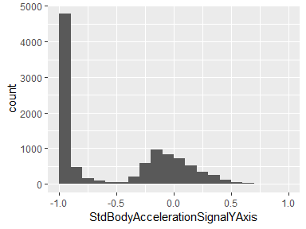

## StdBodyAccelerationSignalZAxis

|  |  |
| --- | --- |
| Feature | Result |
| Variable type | numeric |
| Number of missing obs. | 0 (0 %) |
| Number of unique values | 10297 |
| Median | -0.85 |
| 1st and 3rd quartiles | -0.98; -0.28 |
| Min. and max. | -1; 1 |

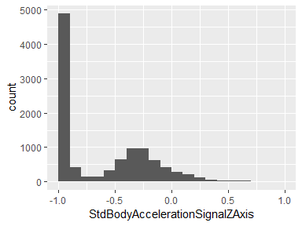

## StdGravityAccelerationSignalXAxis

|  |  |
| --- | --- |
| Feature | Result |
| Variable type | numeric |
| Number of missing obs. | 0 (0 %) |
| Number of unique values | 10288 |
| Median | -0.98 |
| 1st and 3rd quartiles | -0.99; -0.96 |
| Min. and max. | -1; 1 |

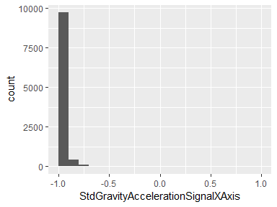

## StdGravityAccelerationSignalYAxis

|  |  |
| --- | --- |
| Feature | Result |
| Variable type | numeric |
| Number of missing obs. | 0 (0 %) |
| Number of unique values | 10293 |
| Median | -0.98 |
| 1st and 3rd quartiles | -0.99; -0.95 |
| Min. and max. | -1; 1 |

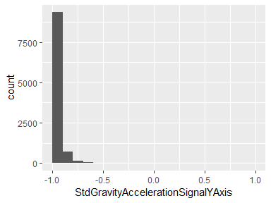

## StdGravityAccelerationSignalZAxis

|  |  |
| --- | --- |
| Feature | Result |
| Variable type | numeric |
| Number of missing obs. | 0 (0 %) |
| Number of unique values | 10296 |
| Median | -0.97 |
| 1st and 3rd quartiles | -0.99; -0.93 |
| Min. and max. | -1; 1 |

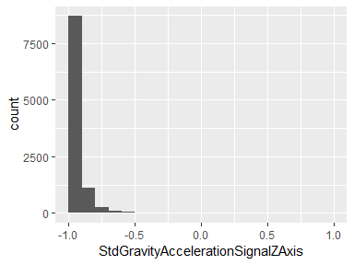

## StdBodyAccelerationJerkSignalXAxis

|  |  |
| --- | --- |
| Feature | Result |
| Variable type | numeric |
| Number of missing obs. | 0 (0 %) |
| Number of unique values | 10290 |
| Median | -0.95 |
| 1st and 3rd quartiles | -0.99; -0.29 |
| Min. and max. | -1; 1 |

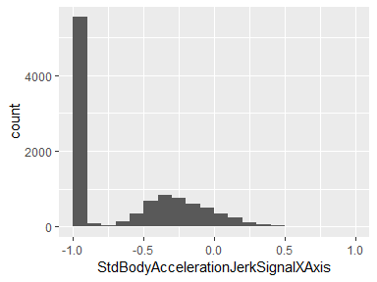

## StdBodyAccelerationJerkSignalYAxis

|  |  |
| --- | --- |
| Feature | Result |
| Variable type | numeric |
| Number of missing obs. | 0 (0 %) |
| Number of unique values | 10296 |
| Median | -0.93 |
| 1st and 3rd quartiles | -0.99; -0.22 |
| Min. and max. | -1; 1 |

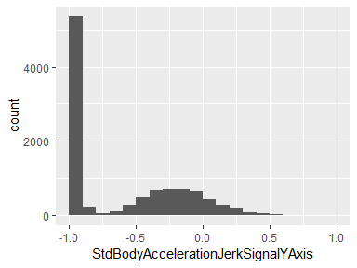

## StdBodyAccelerationJerkSignalZAxis

|  |  |
| --- | --- |
| Feature | Result |
| Variable type | numeric |
| Number of missing obs. | 0 (0 %) |
| Number of unique values | 10293 |
| Median | -0.95 |
| 1st and 3rd quartiles | -0.99; -0.55 |
| Min. and max. | -1; 1 |

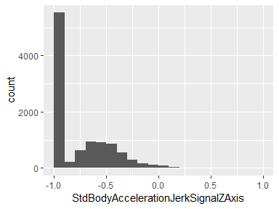

## StdBodyGyroSignalXAxis

|  |  |
| --- | --- |
| Feature | Result |
| Variable type | numeric |
| Number of missing obs. | 0 (0 %) |
| Number of unique values | 10292 |
| Median | -0.9 |
| 1st and 3rd quartiles | -0.99; -0.48 |
| Min. and max. | -1; 1 |

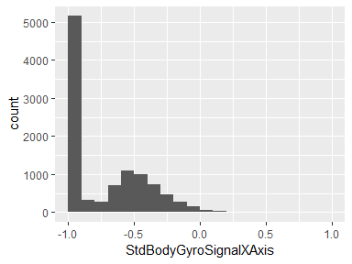

## StdBodyGyroSignalYAxis

|  |  |
| --- | --- |
| Feature | Result |
| Variable type | numeric |
| Number of missing obs. | 0 (0 %) |
| Number of unique values | 10296 |
| Median | -0.91 |
| 1st and 3rd quartiles | -0.98; -0.45 |
| Min. and max. | -1; 1 |

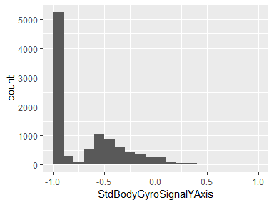

## StdBodyGyroSignalZAxis

|  |  |
| --- | --- |
| Feature | Result |
| Variable type | numeric |
| Number of missing obs. | 0 (0 %) |
| Number of unique values | 10296 |
| Median | -0.88 |
| 1st and 3rd quartiles | -0.99; -0.34 |
| Min. and max. | -1; 1 |

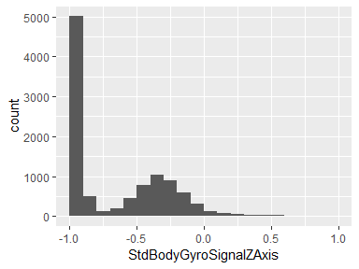

## StdBodyGyroJerkSignalXAxis

|  |  |
| --- | --- |
| Feature | Result |
| Variable type | numeric |
| Number of missing obs. | 0 (0 %) |
| Number of unique values | 10292 |
| Median | -0.93 |
| 1st and 3rd quartiles | -0.99; -0.49 |
| Min. and max. | -1; 1 |

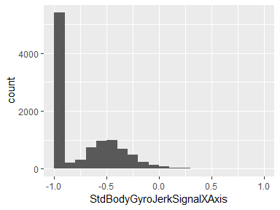

## StdBodyGyroJerkSignalYAxis

|  |  |
| --- | --- |
| Feature | Result |
| Variable type | numeric |
| Number of missing obs. | 0 (0 %) |
| Number of unique values | 10295 |
| Median | -0.95 |
| 1st and 3rd quartiles | -0.99; -0.63 |
| Min. and max. | -1; 1 |

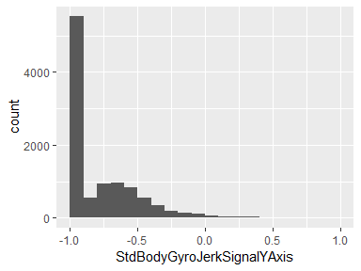

## StdBodyGyroJerkSignalZAxis

|  |  |
| --- | --- |
| Feature | Result |
| Variable type | numeric |
| Number of missing obs. | 0 (0 %) |
| Number of unique values | 10291 |
| Median | -0.95 |
| 1st and 3rd quartiles | -0.99; -0.51 |
| Min. and max. | -1; 1 |

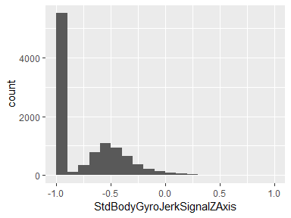

## StdMagnitudeOfBodyAccelerationSignal

|  |  |
| --- | --- |
| Feature | Result |
| Variable type | numeric |
| Number of missing obs. | 0 (0 %) |
| Number of unique values | 10294 |
| Median | -0.84 |
| 1st and 3rd quartiles | -0.98; -0.24 |
| Min. and max. | -1; 1 |

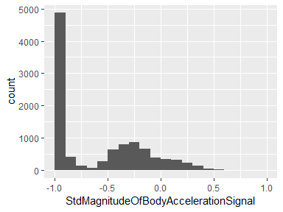

## StdMagnitudeOfGravityAccelerationSignal

|  |  |
| --- | --- |
| Feature | Result |
| Variable type | numeric |
| Number of missing obs. | 0 (0 %) |
| Number of unique values | 10294 |
| Median | -0.84 |
| 1st and 3rd quartiles | -0.98; -0.24 |
| Min. and max. | -1; 1 |

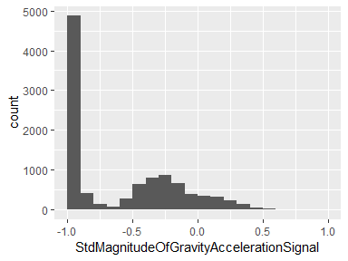

## StdMagnitudeOfBodyAccelerationJerkSignal

|  |  |
| --- | --- |
| Feature | Result |
| Variable type | numeric |
| Number of missing obs. | 0 (0 %) |
| Number of unique values | 10294 |
| Median | -0.93 |
| 1st and 3rd quartiles | -0.99; -0.27 |
| Min. and max. | -1; 1 |

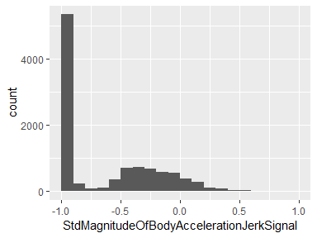

## StdMagnitudeOfBodyGyroSignal

|  |  |
| --- | --- |
| Feature | Result |
| Variable type | numeric |
| Number of missing obs. | 0 (0 %) |
| Number of unique values | 10298 |
| Median | -0.83 |
| 1st and 3rd quartiles | -0.98; -0.39 |
| Min. and max. | -1; 1 |

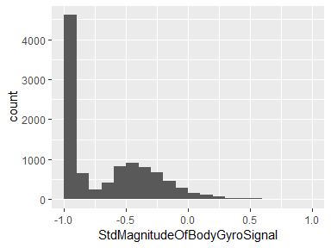

## StdMagnitudeOfBodyGyroJerkSignal

|  |  |
| --- | --- |
| Feature | Result |
| Variable type | numeric |
| Number of missing obs. | 0 (0 %) |
| Number of unique values | 10297 |
| Median | -0.94 |
| 1st and 3rd quartiles | -0.99; -0.61 |
| Min. and max. | -1; 1 |

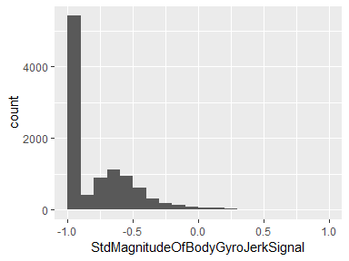

## StdFrequencyDomainBodyAccelerationSignalXAxis

|  |  |
| --- | --- |
| Feature | Result |
| Variable type | numeric |
| Number of missing obs. | 0 (0 %) |
| Number of unique values | 10294 |
| Median | -0.94 |
| 1st and 3rd quartiles | -0.99; -0.25 |
| Min. and max. | -1; 1 |

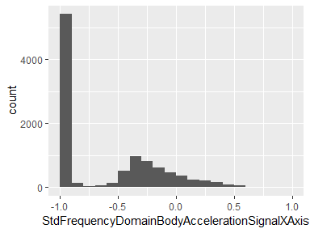

## StdFrequencyDomainBodyAccelerationSignalYAxis

|  |  |
| --- | --- |
| Feature | Result |
| Variable type | numeric |
| Number of missing obs. | 0 (0 %) |
| Number of unique values | 10297 |
| Median | -0.83 |
| 1st and 3rd quartiles | -0.98; -0.09 |
| Min. and max. | -1; 1 |

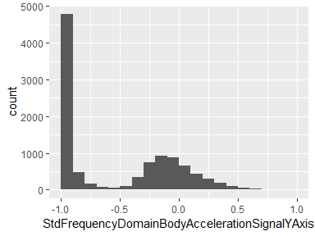

## StdFrequencyDomainBodyAccelerationSignalZAxis

|  |  |
| --- | --- |
| Feature | Result |
| Variable type | numeric |
| Number of missing obs. | 0 (0 %) |
| Number of unique values | 10296 |
| Median | -0.84 |
| 1st and 3rd quartiles | -0.98; -0.3 |
| Min. and max. | -1; 1 |

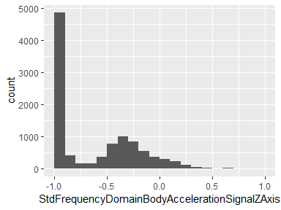

## StdFrequencyDomainBodyAccelerationJerkSignalXAxis

|  |  |
| --- | --- |
| Feature | Result |
| Variable type | numeric |
| Number of missing obs. | 0 (0 %) |
| Number of unique values | 10291 |
| Median | -0.96 |
| 1st and 3rd quartiles | -0.99; -0.32 |
| Min. and max. | -1; 1 |

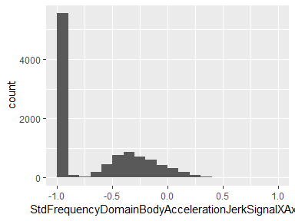

## StdFrequencyDomainBodyAccelerationJerkSignalYAxis

|  |  |
| --- | --- |
| Feature | Result |
| Variable type | numeric |
| Number of missing obs. | 0 (0 %) |
| Number of unique values | 10294 |
| Median | -0.93 |
| 1st and 3rd quartiles | -0.99; -0.24 |
| Min. and max. | -1; 1 |

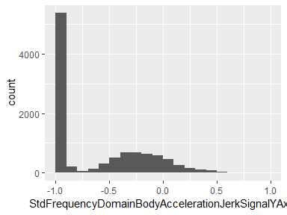

## StdFrequencyDomainBodyAccelerationJerkSignalZAxis

|  |  |
| --- | --- |
| Feature | Result |
| Variable type | numeric |
| Number of missing obs. | 0 (0 %) |
| Number of unique values | 10290 |
| Median | -0.96 |
| 1st and 3rd quartiles | -0.99; -0.59 |
| Min. and max. | -1; 1 |

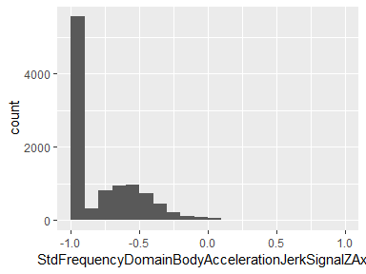

## StdFrequencyDomainBodyGyroSignalXAxis

|  |  |
| --- | --- |
| Feature | Result |
| Variable type | numeric |
| Number of missing obs. | 0 (0 %) |
| Number of unique values | 10297 |
| Median | -0.91 |
| 1st and 3rd quartiles | -0.99; -0.52 |
| Min. and max. | -1; 1 |

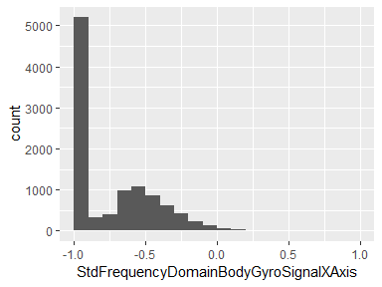

## StdFrequencyDomainBodyGyroSignalYAxis

|  |  |
| --- | --- |
| Feature | Result |
| Variable type | numeric |
| Number of missing obs. | 0 (0 %) |
| Number of unique values | 10293 |
| Median | -0.91 |
| 1st and 3rd quartiles | -0.98; -0.44 |
| Min. and max. | -1; 1 |

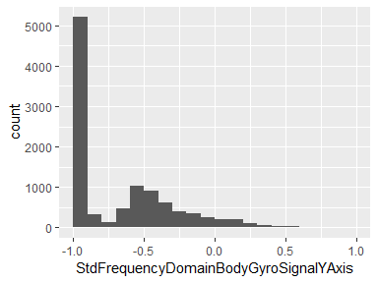

## StdFrequencyDomainBodyGyroSignalZAxis

|  |  |
| --- | --- |
| Feature | Result |
| Variable type | numeric |
| Number of missing obs. | 0 (0 %) |
| Number of unique values | 10295 |
| Median | -0.89 |
| 1st and 3rd quartiles | -0.99; -0.42 |
| Min. and max. | -1; 1 |

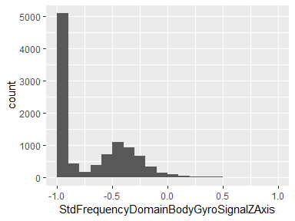

## StdMagnitudeOfBodyAccelerationFrequencyDomainSignal

|  |  |
| --- | --- |
| Feature | Result |
| Variable type | numeric |
| Number of missing obs. | 0 (0 %) |
| Number of unique values | 10298 |
| Median | -0.85 |
| 1st and 3rd quartiles | -0.98; -0.38 |
| Min. and max. | -1; 1 |

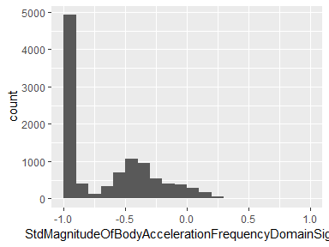

## StdMagnitudeOfBodyAccelerationJerkFrequencyDomainSignal

|  |  |
| --- | --- |
| Feature | Result |
| Variable type | numeric |
| Number of missing obs. | 0 (0 %) |
| Number of unique values | 10296 |
| Median | -0.93 |
| 1st and 3rd quartiles | -0.99; -0.31 |
| Min. and max. | -1; 1 |

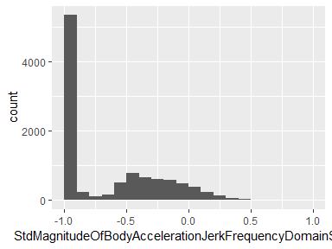

## StdMagnitudeOfBodyGyroFrequencyDomainSignal

|  |  |
| --- | --- |
| Feature | Result |
| Variable type | numeric |
| Number of missing obs. | 0 (0 %) |
| Number of unique values | 10296 |
| Median | -0.83 |
| 1st and 3rd quartiles | -0.98; -0.47 |
| Min. and max. | -1; 1 |

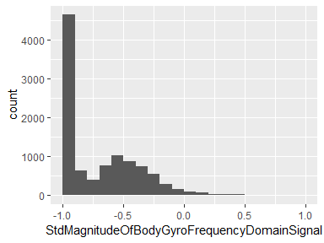

## StdMagnitudeOfBodyGyroJerkFrequencyDomainSignal

|  |  |
| --- | --- |
| Feature | Result |
| Variable type | numeric |
| Number of missing obs. | 0 (0 %) |
| Number of unique values | 10292 |
| Median | -0.94 |
| 1st and 3rd quartiles | -0.99; -0.64 |
| Min. and max. | -1; 1 |

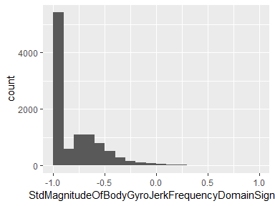

## activitynumber

|  |  |
| --- | --- |
| Feature | Result |
| Variable type | integer |
| Number of missing obs. | 0 (0 %) |
| Number of unique values | 6 |
| Median | 4 |
| 1st and 3rd quartiles | 2; 5 |
| Min. and max. | 1; 6 |

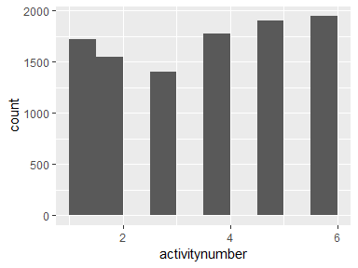

## activityname

|  |  |
| --- | --- |
| Feature | Result |
| Variable type | factor |
| Number of missing obs. | 0 (0 %) |
| Number of unique values | 6 |
| Mode | “LAYING” |
| Reference category | LAYING |

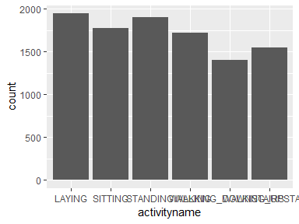

* Observed factor levels: "LAYING", "SITTING", "STANDING", "WALKING", "WALKING_DOWNSTAIRS", "WALKING_UPSTAIRS".

## volunteerid

|  |  |
| --- | --- |
| Feature | Result |
| Variable type | integer |
| Number of missing obs. | 0 (0 %) |
| Number of unique values | 30 |
| Median | 17 |
| 1st and 3rd quartiles | 9; 24 |
| Min. and max. | 1; 30 |

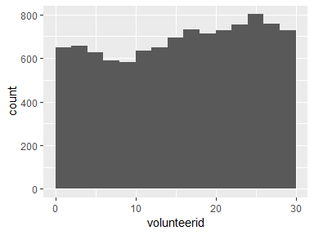

## sample

|  |  |
| --- | --- |
| Feature | Result |
| Variable type | character |
| Number of missing obs. | 0 (0 %) |
| Number of unique values | 2 |
| Mode | “train” |

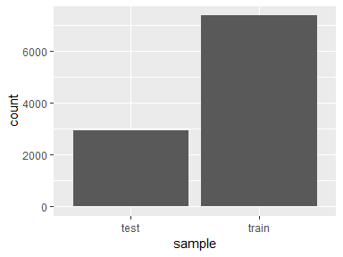

* Observed factor levels: "test", "train".

Report generation information:

* Created by AJ (username: ajohns34).
* Report creation time: Wed May 22 2019 10:31:25
* Report was run from directory: C:/Users/ajohns34/Box/Data Science Specialization/Assignment 5
* dataMaid v1.2.0 [Pkg: 2018-10-03 from CRAN (R 3.5.3)]
* R version 3.5.3 (2019-03-11).
* Platform: x86_64-w64-mingw32/x64 (64-bit)(Windows >= 8 x64 (build 9200)).
* Function call: makeDataReport(data = combined_tidy, mode = c("summarize", "visualize", "check"), smartNum = FALSE, file = "codebook_combined_tidy.Rmd", checks = list(character = "showAllFactorLevels", factor = "showAllFactorLevels", labelled = "showAllFactorLevels", haven_labelled = "showAllFactorLevels", numeric = NULL, integer = NULL, logical = NULL, Date = NULL), listChecks = FALSE, maxProbVals = Inf, codebook = TRUE, reportTitle = "Codebook for combined_tidy")

# Codebook for average_tidy

Autogenerated data summary from dataMaid

2019-05-22 10:31:38

# Data report overview

The dataset examined has the following dimensions:

|  |  |
| --- | --- |
| Feature | Result |
| Number of observations | 180 |
| Number of variables | 68 |

# Codebook summary table

|  |  |  |  |
| --- | --- | --- | --- |
| Variable | Class | # unique values | % Missing |
| **volunteerid** | integer | 30 | 0.00 % |
| **activityname** | factor | 6 | 0.00 % |
| **averageofMeanBodyAccelerationSignalXAxis** | numeric | 180 | 0.00 % |
| **averageofMeanBodyAccelerationSignalYAxis** | numeric | 180 | 0.00 % |
| **averageofMeanBodyAccelerationSignalZAxis** | numeric | 180 | 0.00 % |
| **averageofMeanGravityAccelerationSignalXAxis** | numeric | 180 | 0.00 % |
| **averageofMeanGravityAccelerationSignalYAxis** | numeric | 180 | 0.00 % |
| **averageofMeanGravityAccelerationSignalZAxis** | numeric | 180 | 0.00 % |
| **averageofMeanBodyAccelerationJerkSignalXAxis** | numeric | 180 | 0.00 % |
| **averageofMeanBodyAccelerationJerkSignalYAxis** | numeric | 180 | 0.00 % |
| **averageofMeanBodyAccelerationJerkSignalZAxis** | numeric | 180 | 0.00 % |
| **averageofMeanBodyGyroSignalXAxis** | numeric | 180 | 0.00 % |
| **averageofMeanBodyGyroSignalYAxis** | numeric | 180 | 0.00 % |
| **averageofMeanBodyGyroSignalZAxis** | numeric | 180 | 0.00 % |
| **averageofMeanBodyGyroJerkSignalXAxis** | numeric | 180 | 0.00 % |
| **averageofMeanBodyGyroJerkSignalYAxis** | numeric | 180 | 0.00 % |
| **averageofMeanBodyGyroJerkSignalZAxis** | numeric | 180 | 0.00 % |
| **averageofMeanMagnitudeOfBodyAccelerationSignal** | numeric | 180 | 0.00 % |
| **averageofMeanMagnitudeOfGravityAccelerationSignal** | numeric | 180 | 0.00 % |
| **averageofMeanMagnitudeOfBodyAccelerationJerkSignal** | numeric | 180 | 0.00 % |
| **averageofMeanMagnitudeOfBodyGyroSignal** | numeric | 180 | 0.00 % |
| **averageofMeanMagnitudeOfBodyGyroJerkSignal** | numeric | 180 | 0.00 % |
| **averageofMeanFrequencyDomainBodyAccelerationSignalXAxis** | numeric | 180 | 0.00 % |
| **averageofMeanFrequencyDomainBodyAccelerationSignalYAxis** | numeric | 180 | 0.00 % |
| **averageofMeanFrequencyDomainBodyAccelerationSignalZAxis** | numeric | 180 | 0.00 % |
| **averageofMeanFrequencyDomainBodyAccelerationJerkSignalXAxis** | numeric | 180 | 0.00 % |
| **averageofMeanFrequencyDomainBodyAccelerationJerkSignalYAxis** | numeric | 180 | 0.00 % |
| **averageofMeanFrequencyDomainBodyAccelerationJerkSignalZAxis** | numeric | 180 | 0.00 % |
| **averageofMeanFrequencyDomainBodyGyroSignalXAxis** | numeric | 180 | 0.00 % |
| **averageofMeanFrequencyDomainBodyGyroSignalYAxis** | numeric | 180 | 0.00 % |
| **averageofMeanFrequencyDomainBodyGyroSignalZAxis** | numeric | 180 | 0.00 % |
| **averageofMeanMagnitudeOfBodyAccelerationFrequencyDomainSignal** | numeric | 180 | 0.00 % |
| **averageofMeanMagnitudeOfBodyAccelerationJerkFrequencyDomainSignal** | numeric | 180 | 0.00 % |
| **averageofMeanMagnitudeOfBodyGyroFrequencyDomainSignal** | numeric | 180 | 0.00 % |
| **averageofMeanMagnitudeOfBodyGyroJerkFrequencyDomainSignal** | numeric | 180 | 0.00 % |
| **averageofStdBodyAccelerationSignalXAxis** | numeric | 180 | 0.00 % |
| **averageofStdBodyAccelerationSignalYAxis** | numeric | 180 | 0.00 % |
| **averageofStdBodyAccelerationSignalZAxis** | numeric | 180 | 0.00 % |
| **averageofStdGravityAccelerationSignalXAxis** | numeric | 180 | 0.00 % |
| **averageofStdGravityAccelerationSignalYAxis** | numeric | 180 | 0.00 % |
| **averageofStdGravityAccelerationSignalZAxis** | numeric | 180 | 0.00 % |
| **averageofStdBodyAccelerationJerkSignalXAxis** | numeric | 180 | 0.00 % |
| **averageofStdBodyAccelerationJerkSignalYAxis** | numeric | 180 | 0.00 % |
| **averageofStdBodyAccelerationJerkSignalZAxis** | numeric | 180 | 0.00 % |
| **averageofStdBodyGyroSignalXAxis** | numeric | 180 | 0.00 % |
| **averageofStdBodyGyroSignalYAxis** | numeric | 180 | 0.00 % |
| **averageofStdBodyGyroSignalZAxis** | numeric | 180 | 0.00 % |
| **averageofStdBodyGyroJerkSignalXAxis** | numeric | 180 | 0.00 % |
| **averageofStdBodyGyroJerkSignalYAxis** | numeric | 180 | 0.00 % |
| **averageofStdBodyGyroJerkSignalZAxis** | numeric | 180 | 0.00 % |
| **averageofStdMagnitudeOfBodyAccelerationSignal** | numeric | 180 | 0.00 % |
| **averageofStdMagnitudeOfGravityAccelerationSignal** | numeric | 180 | 0.00 % |
| **averageofStdMagnitudeOfBodyAccelerationJerkSignal** | numeric | 180 | 0.00 % |
| **averageofStdMagnitudeOfBodyGyroSignal** | numeric | 180 | 0.00 % |
| **averageofStdMagnitudeOfBodyGyroJerkSignal** | numeric | 180 | 0.00 % |
| **averageofStdFrequencyDomainBodyAccelerationSignalXAxis** | numeric | 180 | 0.00 % |
| **averageofStdFrequencyDomainBodyAccelerationSignalYAxis** | numeric | 180 | 0.00 % |
| **averageofStdFrequencyDomainBodyAccelerationSignalZAxis** | numeric | 180 | 0.00 % |
| **averageofStdFrequencyDomainBodyAccelerationJerkSignalXAxis** | numeric | 180 | 0.00 % |
| **averageofStdFrequencyDomainBodyAccelerationJerkSignalYAxis** | numeric | 180 | 0.00 % |
| **averageofStdFrequencyDomainBodyAccelerationJerkSignalZAxis** | numeric | 180 | 0.00 % |
| **averageofStdFrequencyDomainBodyGyroSignalXAxis** | numeric | 180 | 0.00 % |
| **averageofStdFrequencyDomainBodyGyroSignalYAxis** | numeric | 180 | 0.00 % |
| **averageofStdFrequencyDomainBodyGyroSignalZAxis** | numeric | 180 | 0.00 % |
| **averageofStdMagnitudeOfBodyAccelerationFrequencyDomainSignal** | numeric | 180 | 0.00 % |
| **averageofStdMagnitudeOfBodyAccelerationJerkFrequencyDomainSignal** | numeric | 180 | 0.00 % |
| **averageofStdMagnitudeOfBodyGyroFrequencyDomainSignal** | numeric | 180 | 0.00 % |
| **averageofStdMagnitudeOfBodyGyroJerkFrequencyDomainSignal** | numeric | 180 | 0.00 % |

# Variable list

## volunteerid

|  |  |
| --- | --- |
| Feature | Result |
| Variable type | integer |
| Number of missing obs. | 0 (0 %) |
| Number of unique values | 30 |
| Median | 15.5 |
| 1st and 3rd quartiles | 8; 23 |
| Min. and max. | 1; 30 |

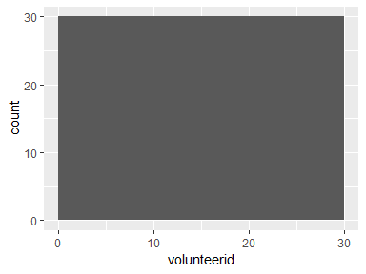

## activityname

|  |  |
| --- | --- |
| Feature | Result |
| Variable type | factor |
| Number of missing obs. | 0 (0 %) |
| Number of unique values | 6 |
| Mode | “LAYING” |
| Reference category | LAYING |

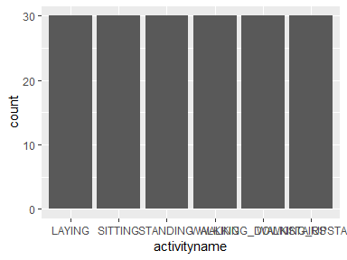

* Observed factor levels: "LAYING", "SITTING", "STANDING", "WALKING", "WALKING_DOWNSTAIRS", "WALKING_UPSTAIRS".

## averageofMeanBodyAccelerationSignalXAxis

|  |  |
| --- | --- |
| Feature | Result |
| Variable type | numeric |
| Number of missing obs. | 0 (0 %) |
| Number of unique values | 180 |
| Median | 0.28 |
| 1st and 3rd quartiles | 0.27; 0.28 |
| Min. and max. | 0.22; 0.3 |

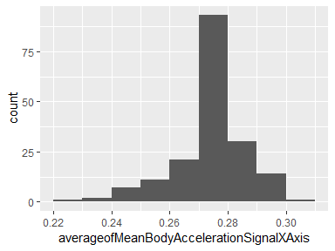

## averageofMeanBodyAccelerationSignalYAxis

|  |  |
| --- | --- |
| Feature | Result |
| Variable type | numeric |
| Number of missing obs. | 0 (0 %) |
| Number of unique values | 180 |
| Median | -0.02 |
| 1st and 3rd quartiles | -0.02; -0.01 |
| Min. and max. | -0.04; 0 |

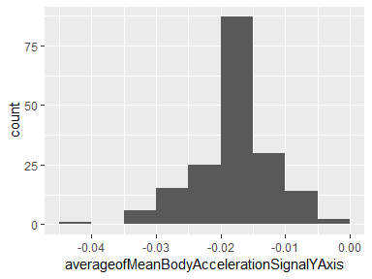

## averageofMeanBodyAccelerationSignalZAxis

|  |  |
| --- | --- |
| Feature | Result |
| Variable type | numeric |
| Number of missing obs. | 0 (0 %) |
| Number of unique values | 180 |
| Median | -0.11 |
| 1st and 3rd quartiles | -0.11; -0.1 |
| Min. and max. | -0.15; -0.08 |

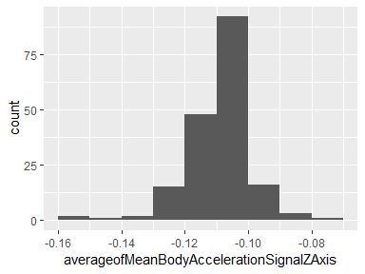

## averageofMeanGravityAccelerationSignalXAxis

|  |  |
| --- | --- |
| Feature | Result |
| Variable type | numeric |
| Number of missing obs. | 0 (0 %) |
| Number of unique values | 180 |
| Median | 0.92 |
| 1st and 3rd quartiles | 0.84; 0.94 |
| Min. and max. | -0.68; 0.97 |

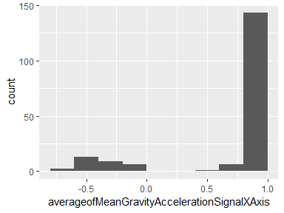

## averageofMeanGravityAccelerationSignalYAxis

|  |  |
| --- | --- |
| Feature | Result |
| Variable type | numeric |
| Number of missing obs. | 0 (0 %) |
| Number of unique values | 180 |
| Median | -0.13 |
| 1st and 3rd quartiles | -0.23; 0.09 |
| Min. and max. | -0.48; 0.96 |

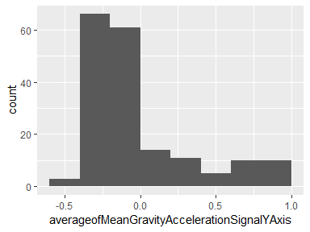

## averageofMeanGravityAccelerationSignalZAxis

|  |  |
| --- | --- |
| Feature | Result |
| Variable type | numeric |
| Number of missing obs. | 0 (0 %) |
| Number of unique values | 180 |
| Median | 0.02 |
| 1st and 3rd quartiles | -0.12; 0.15 |
| Min. and max. | -0.5; 0.96 |

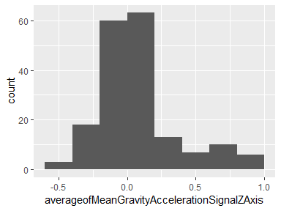

## averageofMeanBodyAccelerationJerkSignalXAxis

|  |  |
| --- | --- |
| Feature | Result |
| Variable type | numeric |
| Number of missing obs. | 0 (0 %) |
| Number of unique values | 180 |
| Median | 0.08 |
| 1st and 3rd quartiles | 0.07; 0.08 |
| Min. and max. | 0.04; 0.13 |

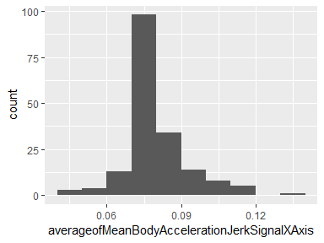

## averageofMeanBodyAccelerationJerkSignalYAxis

|  |  |
| --- | --- |
| Feature | Result |
| Variable type | numeric |
| Number of missing obs. | 0 (0 %) |
| Number of unique values | 180 |
| Median | 0.01 |
| 1st and 3rd quartiles | 0; 0.01 |
| Min. and max. | -0.04; 0.06 |

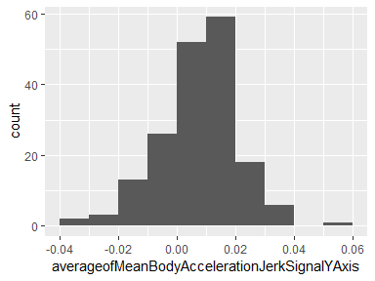

## averageofMeanBodyAccelerationJerkSignalZAxis

|  |  |
| --- | --- |
| Feature | Result |
| Variable type | numeric |
| Number of missing obs. | 0 (0 %) |
| Number of unique values | 180 |
| Median | 0 |
| 1st and 3rd quartiles | -0.01; 0 |
| Min. and max. | -0.07; 0.04 |

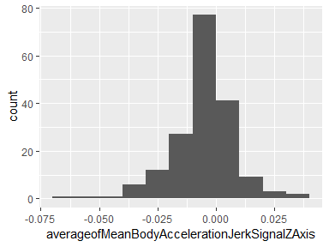

## averageofMeanBodyGyroSignalXAxis

|  |  |
| --- | --- |
| Feature | Result |
| Variable type | numeric |
| Number of missing obs. | 0 (0 %) |
| Number of unique values | 180 |
| Median | -0.03 |
| 1st and 3rd quartiles | -0.05; -0.02 |
| Min. and max. | -0.21; 0.19 |

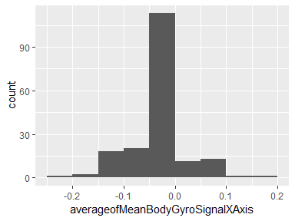

## averageofMeanBodyGyroSignalYAxis

|  |  |
| --- | --- |
| Feature | Result |
| Variable type | numeric |
| Number of missing obs. | 0 (0 %) |
| Number of unique values | 180 |
| Median | -0.07 |
| 1st and 3rd quartiles | -0.09; -0.06 |
| Min. and max. | -0.2; 0.03 |

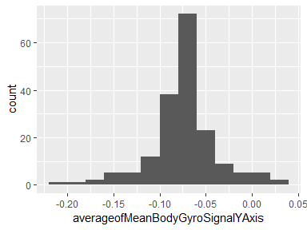

## averageofMeanBodyGyroSignalZAxis

|  |  |
| --- | --- |
| Feature | Result |
| Variable type | numeric |
| Number of missing obs. | 0 (0 %) |
| Number of unique values | 180 |
| Median | 0.09 |
| 1st and 3rd quartiles | 0.07; 0.1 |
| Min. and max. | -0.07; 0.18 |

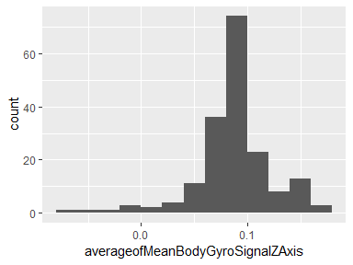

## averageofMeanBodyGyroJerkSignalXAxis

|  |  |
| --- | --- |
| Feature | Result |
| Variable type | numeric |
| Number of missing obs. | 0 (0 %) |
| Number of unique values | 180 |
| Median | -0.1 |
| 1st and 3rd quartiles | -0.1; -0.09 |
| Min. and max. | -0.16; -0.02 |

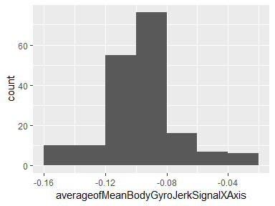

## averageofMeanBodyGyroJerkSignalYAxis

|  |  |
| --- | --- |
| Feature | Result |
| Variable type | numeric |
| Number of missing obs. | 0 (0 %) |
| Number of unique values | 180 |
| Median | -0.04 |
| 1st and 3rd quartiles | -0.05; -0.04 |
| Min. and max. | -0.08; -0.01 |

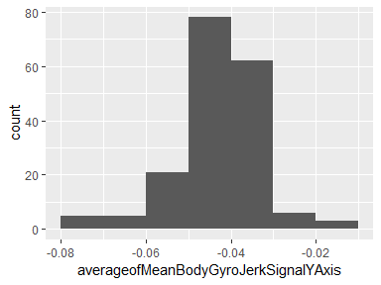

## averageofMeanBodyGyroJerkSignalZAxis

|  |  |
| --- | --- |
| Feature | Result |
| Variable type | numeric |
| Number of missing obs. | 0 (0 %) |
| Number of unique values | 180 |
| Median | -0.05 |
| 1st and 3rd quartiles | -0.06; -0.05 |
| Min. and max. | -0.09; -0.01 |

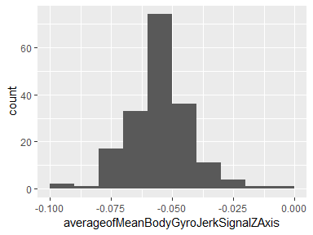

## averageofMeanMagnitudeOfBodyAccelerationSignal

|  |  |
| --- | --- |
| Feature | Result |
| Variable type | numeric |
| Number of missing obs. | 0 (0 %) |
| Number of unique values | 180 |
| Median | -0.48 |
| 1st and 3rd quartiles | -0.96; -0.09 |
| Min. and max. | -0.99; 0.64 |

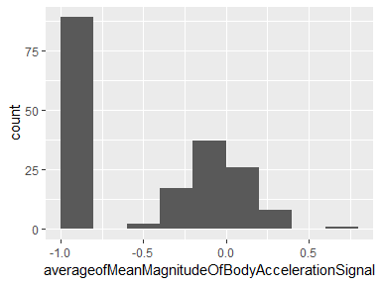

## averageofMeanMagnitudeOfGravityAccelerationSignal

|  |  |
| --- | --- |
| Feature | Result |
| Variable type | numeric |
| Number of missing obs. | 0 (0 %) |
| Number of unique values | 180 |
| Median | -0.48 |
| 1st and 3rd quartiles | -0.96; -0.09 |
| Min. and max. | -0.99; 0.64 |

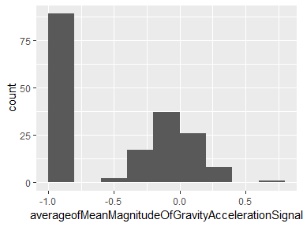

## averageofMeanMagnitudeOfBodyAccelerationJerkSignal

|  |  |
| --- | --- |
| Feature | Result |
| Variable type | numeric |
| Number of missing obs. | 0 (0 %) |
| Number of unique values | 180 |
| Median | -0.82 |
| 1st and 3rd quartiles | -0.98; -0.25 |
| Min. and max. | -0.99; 0.43 |

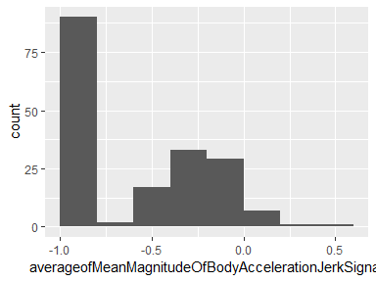

## averageofMeanMagnitudeOfBodyGyroSignal

|  |  |
| --- | --- |
| Feature | Result |
| Variable type | numeric |
| Number of missing obs. | 0 (0 %) |
| Number of unique values | 180 |
| Median | -0.66 |
| 1st and 3rd quartiles | -0.95; -0.22 |
| Min. and max. | -0.98; 0.42 |

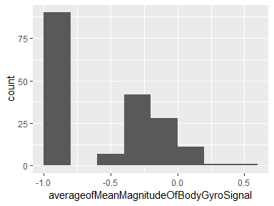

## averageofMeanMagnitudeOfBodyGyroJerkSignal

|  |  |
| --- | --- |
| Feature | Result |
| Variable type | numeric |
| Number of missing obs. | 0 (0 %) |
| Number of unique values | 180 |
| Median | -0.86 |
| 1st and 3rd quartiles | -0.99; -0.51 |
| Min. and max. | -1; 0.09 |

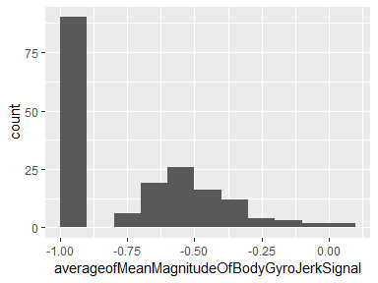

## averageofMeanFrequencyDomainBodyAccelerationSignalXAxis

|  |  |
| --- | --- |
| Feature | Result |
| Variable type | numeric |
| Number of missing obs. | 0 (0 %) |
| Number of unique values | 180 |
| Median | -0.77 |
| 1st and 3rd quartiles | -0.98; -0.22 |
| Min. and max. | -1; 0.54 |

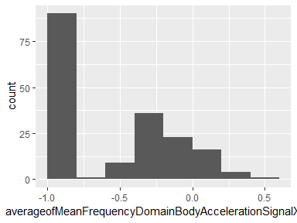

## averageofMeanFrequencyDomainBodyAccelerationSignalYAxis

|  |  |
| --- | --- |
| Feature | Result |
| Variable type | numeric |
| Number of missing obs. | 0 (0 %) |
| Number of unique values | 180 |
| Median | -0.59 |
| 1st and 3rd quartiles | -0.95; -0.06 |
| Min. and max. | -0.99; 0.52 |

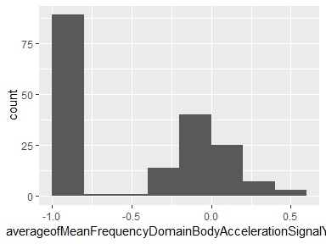

## averageofMeanFrequencyDomainBodyAccelerationSignalZAxis

|  |  |
| --- | --- |
| Feature | Result |
| Variable type | numeric |
| Number of missing obs. | 0 (0 %) |
| Number of unique values | 180 |
| Median | -0.72 |
| 1st and 3rd quartiles | -0.96; -0.32 |
| Min. and max. | -0.99; 0.28 |

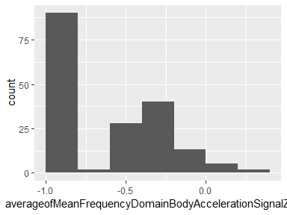

## averageofMeanFrequencyDomainBodyAccelerationJerkSignalXAxis

|  |  |
| --- | --- |
| Feature | Result |
| Variable type | numeric |
| Number of missing obs. | 0 (0 %) |
| Number of unique values | 180 |
| Median | -0.81 |
| 1st and 3rd quartiles | -0.98; -0.28 |
| Min. and max. | -0.99; 0.47 |

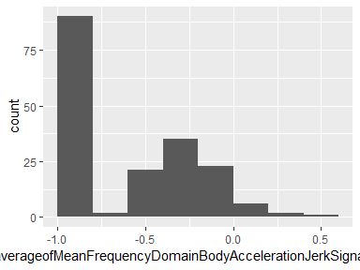

## averageofMeanFrequencyDomainBodyAccelerationJerkSignalYAxis

|  |  |
| --- | --- |
| Feature | Result |
| Variable type | numeric |
| Number of missing obs. | 0 (0 %) |
| Number of unique values | 180 |
| Median | -0.78 |
| 1st and 3rd quartiles | -0.97; -0.2 |
| Min. and max. | -0.99; 0.28 |

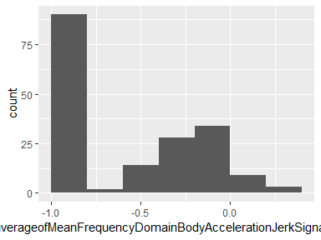

## averageofMeanFrequencyDomainBodyAccelerationJerkSignalZAxis

|  |  |
| --- | --- |
| Feature | Result |
| Variable type | numeric |
| Number of missing obs. | 0 (0 %) |
| Number of unique values | 180 |
| Median | -0.87 |
| 1st and 3rd quartiles | -0.98; -0.47 |
| Min. and max. | -0.99; 0.16 |

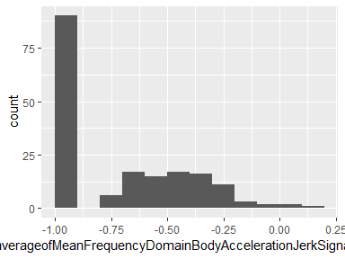

## averageofMeanFrequencyDomainBodyGyroSignalXAxis

|  |  |
| --- | --- |
| Feature | Result |
| Variable type | numeric |
| Number of missing obs. | 0 (0 %) |
| Number of unique values | 180 |
| Median | -0.73 |
| 1st and 3rd quartiles | -0.97; -0.34 |
| Min. and max. | -0.99; 0.47 |

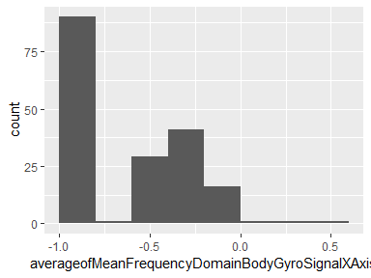

## averageofMeanFrequencyDomainBodyGyroSignalYAxis

|  |  |
| --- | --- |
| Feature | Result |
| Variable type | numeric |
| Number of missing obs. | 0 (0 %) |
| Number of unique values | 180 |
| Median | -0.81 |
| 1st and 3rd quartiles | -0.97; -0.45 |
| Min. and max. | -0.99; 0.33 |

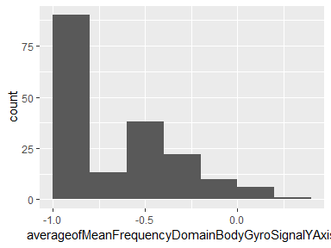

## averageofMeanFrequencyDomainBodyGyroSignalZAxis

|  |  |
| --- | --- |
| Feature | Result |
| Variable type | numeric |
| Number of missing obs. | 0 (0 %) |
| Number of unique values | 180 |
| Median | -0.79 |
| 1st and 3rd quartiles | -0.96; -0.26 |
| Min. and max. | -0.99; 0.49 |

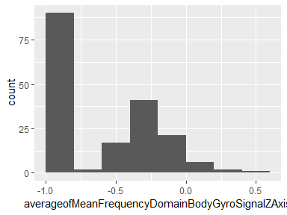

## averageofMeanMagnitudeOfBodyAccelerationFrequencyDomainSignal

|  |  |
| --- | --- |
| Feature | Result |
| Variable type | numeric |
| Number of missing obs. | 0 (0 %) |
| Number of unique values | 180 |
| Median | -0.67 |
| 1st and 3rd quartiles | -0.96; -0.16 |
| Min. and max. | -0.99; 0.59 |

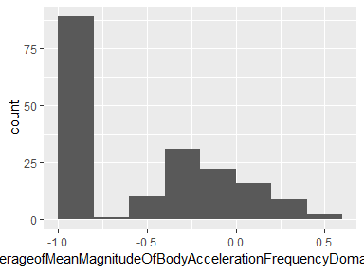

## averageofMeanMagnitudeOfBodyAccelerationJerkFrequencyDomainSignal

|  |  |
| --- | --- |
| Feature | Result |
| Variable type | numeric |
| Number of missing obs. | 0 (0 %) |
| Number of unique values | 180 |
| Median | -0.79 |
| 1st and 3rd quartiles | -0.98; -0.19 |
| Min. and max. | -0.99; 0.54 |

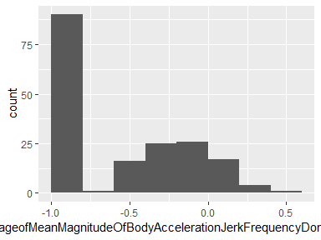

## averageofMeanMagnitudeOfBodyGyroFrequencyDomainSignal

|  |  |
| --- | --- |
| Feature | Result |
| Variable type | numeric |
| Number of missing obs. | 0 (0 %) |
| Number of unique values | 180 |
| Median | -0.77 |
| 1st and 3rd quartiles | -0.96; -0.41 |
| Min. and max. | -0.99; 0.2 |

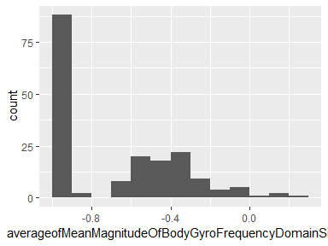

## averageofMeanMagnitudeOfBodyGyroJerkFrequencyDomainSignal

|  |  |
| --- | --- |
| Feature | Result |
| Variable type | numeric |
| Number of missing obs. | 0 (0 %) |
| Number of unique values | 180 |
| Median | -0.88 |
| 1st and 3rd quartiles | -0.98; -0.58 |
| Min. and max. | -1; 0.15 |

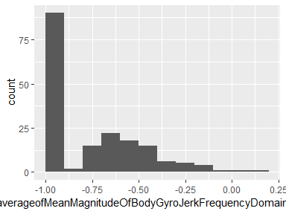

## averageofStdBodyAccelerationSignalXAxis

|  |  |
| --- | --- |
| Feature | Result |
| Variable type | numeric |
| Number of missing obs. | 0 (0 %) |
| Number of unique values | 180 |
| Median | -0.75 |
| 1st and 3rd quartiles | -0.98; -0.2 |
| Min. and max. | -1; 0.63 |

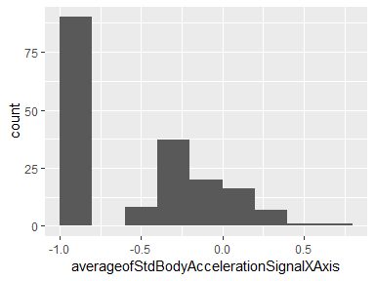

## averageofStdBodyAccelerationSignalYAxis

|  |  |
| --- | --- |
| Feature | Result |
| Variable type | numeric |
| Number of missing obs. | 0 (0 %) |
| Number of unique values | 180 |
| Median | -0.51 |
| 1st and 3rd quartiles | -0.94; -0.03 |
| Min. and max. | -0.99; 0.62 |

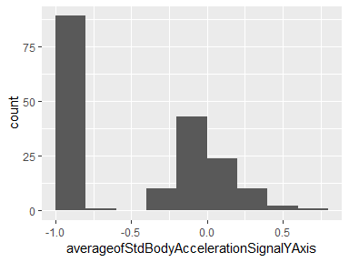

## averageofStdBodyAccelerationSignalZAxis

|  |  |
| --- | --- |
| Feature | Result |
| Variable type | numeric |
| Number of missing obs. | 0 (0 %) |
| Number of unique values | 180 |
| Median | -0.65 |
| 1st and 3rd quartiles | -0.95; -0.23 |
| Min. and max. | -0.99; 0.61 |

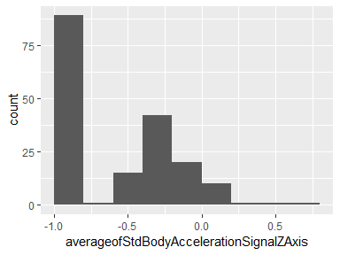

## averageofStdGravityAccelerationSignalXAxis

|  |  |
| --- | --- |
| Feature | Result |
| Variable type | numeric |
| Number of missing obs. | 0 (0 %) |
| Number of unique values | 180 |
| Median | -0.97 |
| 1st and 3rd quartiles | -0.98; -0.95 |
| Min. and max. | -1; -0.83 |

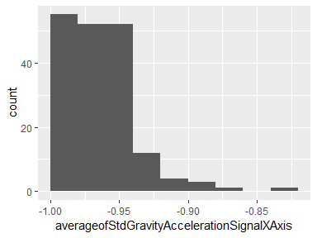

## averageofStdGravityAccelerationSignalYAxis

|  |  |
| --- | --- |
| Feature | Result |
| Variable type | numeric |
| Number of missing obs. | 0 (0 %) |
| Number of unique values | 180 |
| Median | -0.96 |
| 1st and 3rd quartiles | -0.97; -0.94 |
| Min. and max. | -0.99; -0.64 |

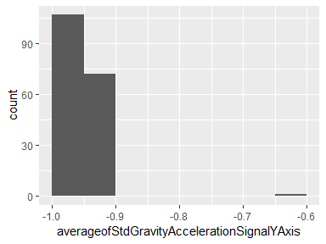

## averageofStdGravityAccelerationSignalZAxis

|  |  |
| --- | --- |
| Feature | Result |
| Variable type | numeric |
| Number of missing obs. | 0 (0 %) |
| Number of unique values | 180 |
| Median | -0.95 |
| 1st and 3rd quartiles | -0.96; -0.92 |
| Min. and max. | -0.99; -0.61 |

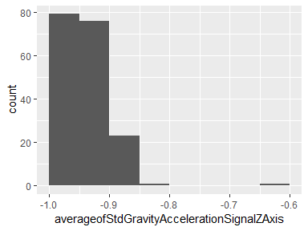

## averageofStdBodyAccelerationJerkSignalXAxis

|  |  |
| --- | --- |
| Feature | Result |
| Variable type | numeric |
| Number of missing obs. | 0 (0 %) |
| Number of unique values | 180 |
| Median | -0.81 |
| 1st and 3rd quartiles | -0.98; -0.22 |
| Min. and max. | -0.99; 0.54 |

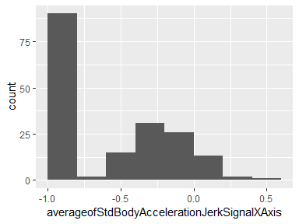

## averageofStdBodyAccelerationJerkSignalYAxis

|  |  |
| --- | --- |
| Feature | Result |
| Variable type | numeric |
| Number of missing obs. | 0 (0 %) |
| Number of unique values | 180 |
| Median | -0.78 |
| 1st and 3rd quartiles | -0.97; -0.15 |
| Min. and max. | -0.99; 0.36 |

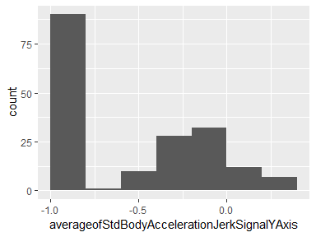

## averageofStdBodyAccelerationJerkSignalZAxis

|  |  |
| --- | --- |
| Feature | Result |
| Variable type | numeric |
| Number of missing obs. | 0 (0 %) |
| Number of unique values | 180 |
| Median | -0.88 |
| 1st and 3rd quartiles | -0.98; -0.51 |
| Min. and max. | -0.99; 0.03 |

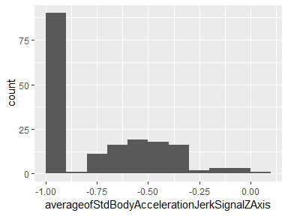

## averageofStdBodyGyroSignalXAxis

|  |  |
| --- | --- |
| Feature | Result |
| Variable type | numeric |
| Number of missing obs. | 0 (0 %) |
| Number of unique values | 180 |
| Median | -0.79 |
| 1st and 3rd quartiles | -0.97; -0.44 |
| Min. and max. | -0.99; 0.27 |

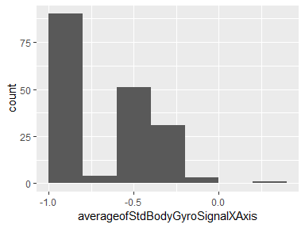

## averageofStdBodyGyroSignalYAxis

|  |  |
| --- | --- |
| Feature | Result |
| Variable type | numeric |
| Number of missing obs. | 0 (0 %) |
| Number of unique values | 180 |
| Median | -0.8 |
| 1st and 3rd quartiles | -0.96; -0.42 |
| Min. and max. | -0.99; 0.48 |

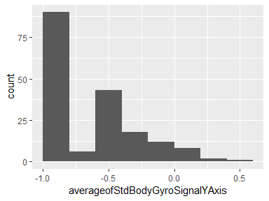

## averageofStdBodyGyroSignalZAxis

|  |  |
| --- | --- |
| Feature | Result |
| Variable type | numeric |
| Number of missing obs. | 0 (0 %) |
| Number of unique values | 180 |
| Median | -0.8 |
| 1st and 3rd quartiles | -0.96; -0.31 |
| Min. and max. | -0.99; 0.56 |

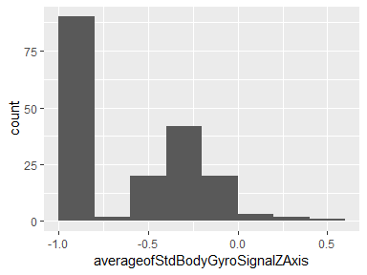

## averageofStdBodyGyroJerkSignalXAxis

|  |  |
| --- | --- |
| Feature | Result |
| Variable type | numeric |
| Number of missing obs. | 0 (0 %) |
| Number of unique values | 180 |
| Median | -0.84 |
| 1st and 3rd quartiles | -0.98; -0.46 |
| Min. and max. | -1; 0.18 |

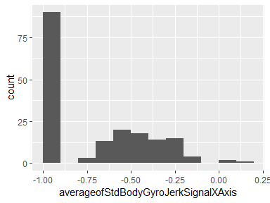

## averageofStdBodyGyroJerkSignalYAxis

|  |  |
| --- | --- |
| Feature | Result |
| Variable type | numeric |
| Number of missing obs. | 0 (0 %) |
| Number of unique values | 180 |
| Median | -0.89 |
| 1st and 3rd quartiles | -0.98; -0.59 |
| Min. and max. | -1; 0.3 |

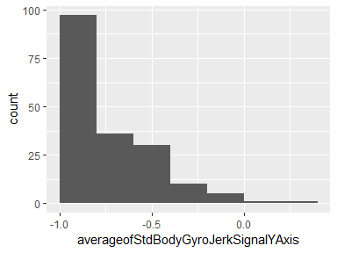

## averageofStdBodyGyroJerkSignalZAxis

|  |  |
| --- | --- |
| Feature | Result |
| Variable type | numeric |
| Number of missing obs. | 0 (0 %) |
| Number of unique values | 180 |
| Median | -0.86 |
| 1st and 3rd quartiles | -0.98; -0.47 |
| Min. and max. | -1; 0.19 |

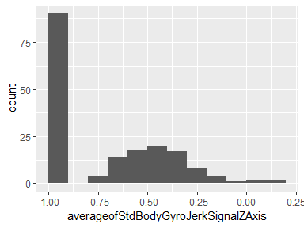

## averageofStdMagnitudeOfBodyAccelerationSignal

|  |  |
| --- | --- |
| Feature | Result |
| Variable type | numeric |
| Number of missing obs. | 0 (0 %) |
| Number of unique values | 180 |
| Median | -0.61 |
| 1st and 3rd quartiles | -0.94; -0.21 |
| Min. and max. | -0.99; 0.43 |

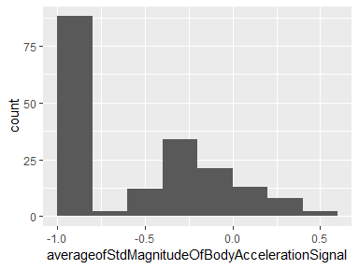

## averageofStdMagnitudeOfGravityAccelerationSignal

|  |  |
| --- | --- |
| Feature | Result |
| Variable type | numeric |
| Number of missing obs. | 0 (0 %) |
| Number of unique values | 180 |
| Median | -0.61 |
| 1st and 3rd quartiles | -0.94; -0.21 |
| Min. and max. | -0.99; 0.43 |

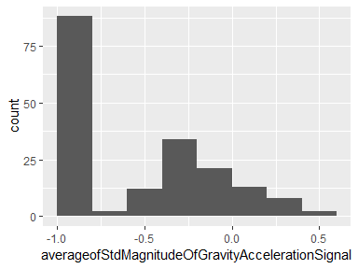

## averageofStdMagnitudeOfBodyAccelerationJerkSignal

|  |  |
| --- | --- |
| Feature | Result |
| Variable type | numeric |
| Number of missing obs. | 0 (0 %) |
| Number of unique values | 180 |
| Median | -0.8 |
| 1st and 3rd quartiles | -0.98; -0.22 |
| Min. and max. | -0.99; 0.45 |

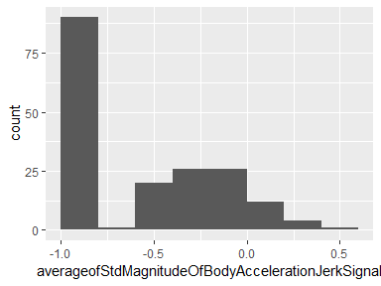

## averageofStdMagnitudeOfBodyGyroSignal

|  |  |
| --- | --- |
| Feature | Result |
| Variable type | numeric |
| Number of missing obs. | 0 (0 %) |
| Number of unique values | 180 |
| Median | -0.74 |
| 1st and 3rd quartiles | -0.95; -0.36 |
| Min. and max. | -0.98; 0.3 |

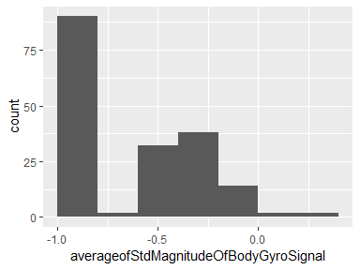

## averageofStdMagnitudeOfBodyGyroJerkSignal

|  |  |
| --- | --- |
| Feature | Result |
| Variable type | numeric |
| Number of missing obs. | 0 (0 %) |
| Number of unique values | 180 |
| Median | -0.88 |
| 1st and 3rd quartiles | -0.98; -0.58 |
| Min. and max. | -1; 0.25 |

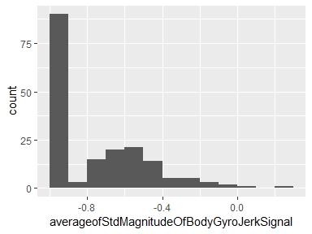

## averageofStdFrequencyDomainBodyAccelerationSignalXAxis

|  |  |
| --- | --- |
| Feature | Result |
| Variable type | numeric |
| Number of missing obs. | 0 (0 %) |
| Number of unique values | 180 |
| Median | -0.75 |
| 1st and 3rd quartiles | -0.98; -0.2 |
| Min. and max. | -1; 0.66 |

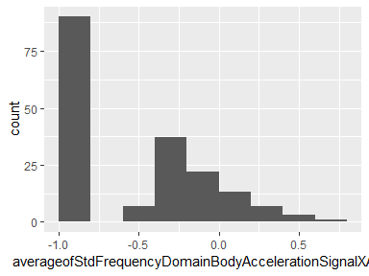

## averageofStdFrequencyDomainBodyAccelerationSignalYAxis

|  |  |
| --- | --- |
| Feature | Result |
| Variable type | numeric |
| Number of missing obs. | 0 (0 %) |
| Number of unique values | 180 |
| Median | -0.51 |
| 1st and 3rd quartiles | -0.94; -0.08 |
| Min. and max. | -0.99; 0.56 |

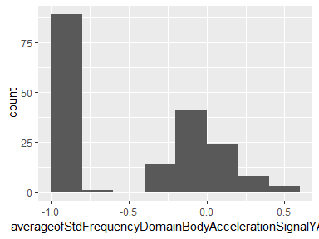

## averageofStdFrequencyDomainBodyAccelerationSignalZAxis

|  |  |
| --- | --- |
| Feature | Result |
| Variable type | numeric |
| Number of missing obs. | 0 (0 %) |
| Number of unique values | 180 |
| Median | -0.64 |
| 1st and 3rd quartiles | -0.95; -0.27 |
| Min. and max. | -0.99; 0.69 |

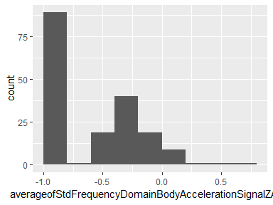

## averageofStdFrequencyDomainBodyAccelerationJerkSignalXAxis

|  |  |
| --- | --- |
| Feature | Result |
| Variable type | numeric |
| Number of missing obs. | 0 (0 %) |
| Number of unique values | 180 |
| Median | -0.83 |
| 1st and 3rd quartiles | -0.98; -0.25 |
| Min. and max. | -1; 0.48 |

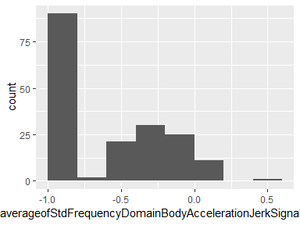

## averageofStdFrequencyDomainBodyAccelerationJerkSignalYAxis

|  |  |
| --- | --- |
| Feature | Result |
| Variable type | numeric |
| Number of missing obs. | 0 (0 %) |
| Number of unique values | 180 |
| Median | -0.79 |
| 1st and 3rd quartiles | -0.97; -0.17 |
| Min. and max. | -0.99; 0.35 |

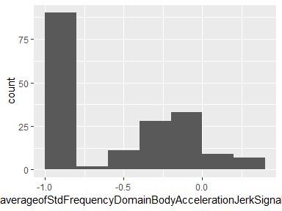

## averageofStdFrequencyDomainBodyAccelerationJerkSignalZAxis

|  |  |
| --- | --- |
| Feature | Result |
| Variable type | numeric |
| Number of missing obs. | 0 (0 %) |
| Number of unique values | 180 |
| Median | -0.9 |
| 1st and 3rd quartiles | -0.98; -0.54 |
| Min. and max. | -0.99; -0.01 |

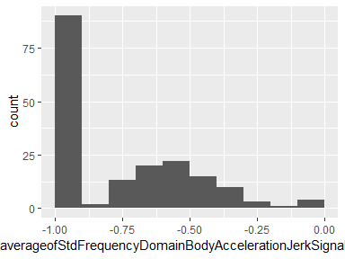

## averageofStdFrequencyDomainBodyGyroSignalXAxis

|  |  |
| --- | --- |
| Feature | Result |
| Variable type | numeric |
| Number of missing obs. | 0 (0 %) |
| Number of unique values | 180 |
| Median | -0.81 |
| 1st and 3rd quartiles | -0.98; -0.48 |
| Min. and max. | -0.99; 0.2 |

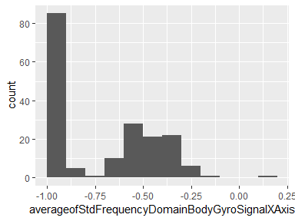

## averageofStdFrequencyDomainBodyGyroSignalYAxis

|  |  |
| --- | --- |
| Feature | Result |
| Variable type | numeric |
| Number of missing obs. | 0 (0 %) |
| Number of unique values | 180 |
| Median | -0.8 |
| 1st and 3rd quartiles | -0.96; -0.42 |
| Min. and max. | -0.99; 0.65 |

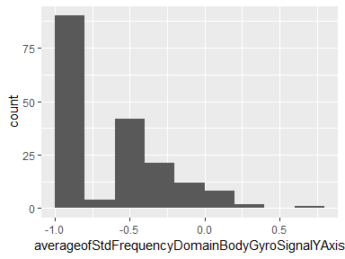

## averageofStdFrequencyDomainBodyGyroSignalZAxis

|  |  |
| --- | --- |
| Feature | Result |
| Variable type | numeric |
| Number of missing obs. | 0 (0 %) |
| Number of unique values | 180 |
| Median | -0.82 |
| 1st and 3rd quartiles | -0.96; -0.39 |
| Min. and max. | -0.99; 0.52 |

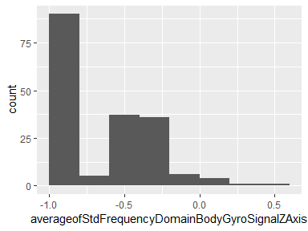

## averageofStdMagnitudeOfBodyAccelerationFrequencyDomainSignal

|  |  |
| --- | --- |
| Feature | Result |
| Variable type | numeric |
| Number of missing obs. | 0 (0 %) |
| Number of unique values | 180 |
| Median | -0.65 |
| 1st and 3rd quartiles | -0.95; -0.37 |
| Min. and max. | -0.99; 0.18 |

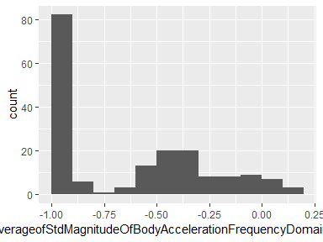

## averageofStdMagnitudeOfBodyAccelerationJerkFrequencyDomainSignal

|  |  |
| --- | --- |
| Feature | Result |
| Variable type | numeric |
| Number of missing obs. | 0 (0 %) |
| Number of unique values | 180 |
| Median | -0.81 |
| 1st and 3rd quartiles | -0.98; -0.27 |
| Min. and max. | -0.99; 0.32 |

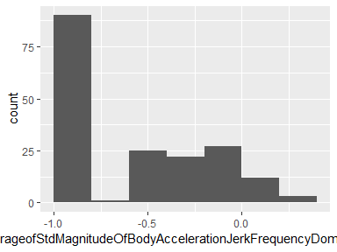

## averageofStdMagnitudeOfBodyGyroFrequencyDomainSignal

|  |  |
| --- | --- |
| Feature | Result |
| Variable type | numeric |
| Number of missing obs. | 0 (0 %) |
| Number of unique values | 180 |
| Median | -0.77 |
| 1st and 3rd quartiles | -0.95; -0.43 |
| Min. and max. | -0.98; 0.24 |

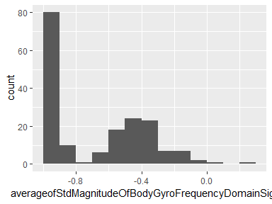

## averageofStdMagnitudeOfBodyGyroJerkFrequencyDomainSignal

|  |  |
| --- | --- |
| Feature | Result |
| Variable type | numeric |
| Number of missing obs. | 0 (0 %) |
| Number of unique values | 180 |
| Median | -0.89 |
| 1st and 3rd quartiles | -0.98; -0.61 |
| Min. and max. | -1; 0.29 |

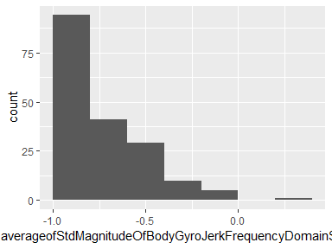

Report generation information:

* Created by AJ (username: ajohns34).
* Report creation time: Wed May 22 2019 10:31:41
* Report was run from directory: C:/Users/ajohns34/Box/Data Science Specialization/Assignment 5
* dataMaid v1.2.0 [Pkg: 2018-10-03 from CRAN (R 3.5.3)]
* R version 3.5.3 (2019-03-11).
* Platform: x86_64-w64-mingw32/x64 (64-bit)(Windows >= 8 x64 (build 9200)).
* Function call: makeDataReport(data = average_tidy, mode = c("summarize", "visualize", "check"), smartNum = FALSE, file = "codebook_average_tidy.Rmd", checks = list(character = "showAllFactorLevels", factor = "showAllFactorLevels", labelled = "showAllFactorLevels", haven_labelled = "showAllFactorLevels", numeric = NULL, integer = NULL, logical = NULL, Date = NULL), listChecks = FALSE, maxProbVals = Inf, codebook = TRUE, reportTitle = "Codebook for average_tidy")